



**Dissertation Title: Investigating and evaluating the relationship between economic crises and financial policy reform.**

**Master title: MSc. Finance and Investment**

**Name: Balbir Singh**

**Year: Feb. 2021**

# Abstract

Point of view in this paper we will compare the two most massive crises were happen ever in the world the first crisis was the mortgage global financial crisis which happened in 2008 and the second was the global pandemic Covid-19 which affected the inflation measured by the consumer price index, in Sweden and World Health Organisation. the constancy and seriousness of financial crises (Aliber, 2015). In 2007 the global crisis, the most and largest aspect in the world affected the mortgage global financial crisis, leading to the globalization of the crisis, and destroying and collapse of the financial market (Aliber, 2015). In this dissertation, in my first attempt, we will review the different economic breakdowns, the previous financial crises affected different previous financial crises. for the examiner some of the previous financial crises the researcher's thinking is very important to ascertain the differences between those ones and the last crisis and consequences. and then how that crisis effect on rest of the world. In fact, policy owners have been trying to establish different types of plans, policies, and solutions. To that end, we will assess and analyse the main, why the bubble economy and financial crisis was exploded. then we will see the reason behind it and the impact of the crisis, the mass destruction in most countries' economies and health sector got failed to recover and still going on come to reality, according to the WHO report the millions of number death case showing the effect on the humanity which is directly affected on the economy, This present study including the health challenges and global economic crisis primarily emphasizes seeking COVID-19. due to the virus, continues to hit the global health sector and mainly hit the global economy adversely, after three wave was recorded, as a result, 174.117 million people got affected by the coronavirus, and the death count was recorded at 3.75 million.

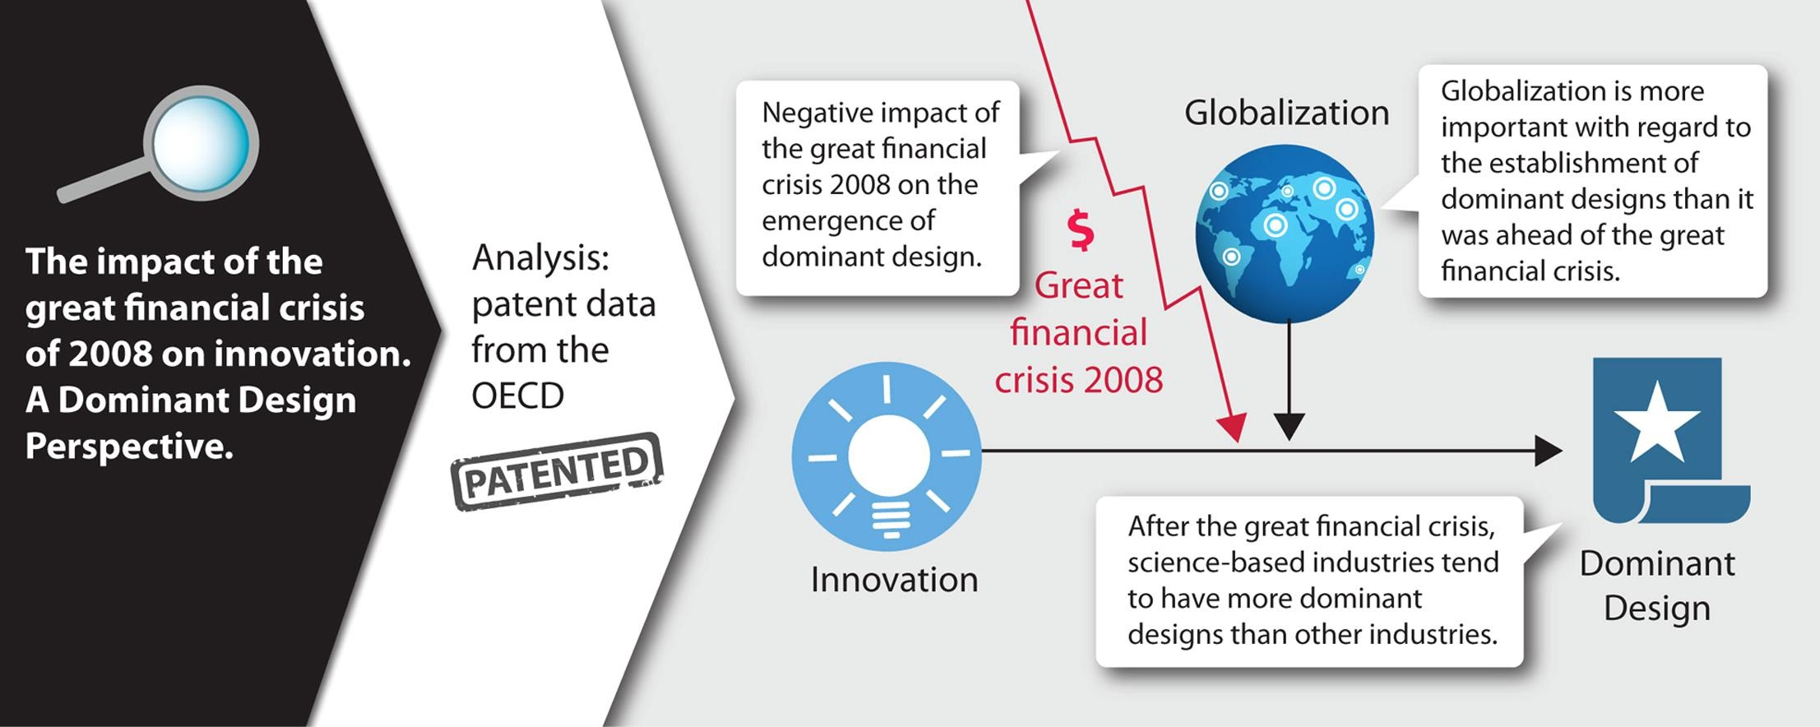

Keywords  
The Financial crisis, Covid-19, pandemic, effects, CPI, inflation, basket, GDP growth, unemployment, and money supply.

# Contents

The Financial crisis, Covid-19, pandemic, effects, CPI, inflation, basket, GDP growth, unemployment, and money supply.

Table of Contents

Abstract 2

Keywords 3

Contents 4

Acknowledgements 6

Dissertation Thesis 8

Introduction 9

Mortgage Global Financial Crisis 9

Brief Methodology description 9

Aims and Objectives 11

A brief description of the topic 12

Chapter One – Literature Review I 14

Covid-19 Crisis 18

Chapter Two – Literature review II 21

Financial crises and financial policy reform 21

Gap in the Literature 25

Chapter Three – Methodology 26

Data description and sources: 26

Research philosophy 28

Chapter Four – Findings / Analysis / Discussion 33

Findings 33

Analysis 34

Discussion 35

Effects of the Global Financial Crisis on the unemployment rate 37

Inflation rate 38

Impact on Big Four Banks 39

Effects of the COVID-19 39

Policy implications 42

Conclusion 44

Concluding Remarks 47

Bibliography 49

APPENDIX 53

# Acknowledgements

First of all, I would like to express my sincere gratitude and would like to thank especially some of the people which I am following, without their guidance and support whom I would not have been able to complete my dissertation research paper, and without whom I would not have made it through my master’s degree! Professor Mr. Konstantinos skamagkas Ph.D. at BSBI college, with the help him and whose insight and knowledge into the subject matter steered me through this research. And special thanks to Upasana my colleague, whose support as part of her knowledge allowed my studies to go the extra mile.

The residents of Kuuku Obiri my other colleague, took his precious time to return surveys and allowed me into your homes for follow-up surveys, and without him, I couldn’t imagine without his help and assistance, and I would have no content for my thesis.

And my biggest thanks to my family for all the love and support you have shown me through this research, the culmination of two years of learning. And for my wife pooja, thanks for all your support, without which I would have stopped these studies a long time ago, you have been amazing.

**Statement of compliance with academic ethics and the avoidance of plagiarism**

I honestly declare that this dissertation is entirely my own work and none of its part has been copied from printed or electronic sources, translated from foreign sources and reproduced from essays of other researchers or students. Wherever I have been based on ideas or other people texts I clearly declare it through the good use of references following academic ethics.

(In the case that is proved that part of the essay does not constitute an original work, but a copy of an already published essay or from another source, the student will be expelled permanently from the postgraduate program).

Name and Surname (Capital letters):

BALBIR SINGH

Date: 28/06/2023

# Dissertation Thesis

(leave this page empty)

# Introduction

## Mortgage Global Financial Crisis

It's to understand the primordial that, it was said that in the aspect of the economy in the global when all the countries facing a huge amount of suffering from the financial and economic crisis then especially in the United States of America, time era in between 2006-2007. Nonetheless, the losses are not what we expected in terms of GDP but those suffered by some individual countries during deep crises in the past.

(See Chart 1).

there is one more measure that causes the degree of the market and makes more stress. according to the official data of The IMF’s October 2008 World Economic Outlook (Drazen, 2011) the index was calculated for the financial crisis as well, after the time of 1980 the total 17 numbers of advanced economies were calibrated.

(See Chart 2).

according to several events data and their programs, it spreads occasions according to the domino effect and first went and start with the countryside recession in the United States of America and by the time and later it spread to many other countries as well in the rest of the world.

(See Chart) Source: WHO mortality data base, 2010 (data collection from 29 countries).

## Brief Methodology description

A: For methodology, the method which is used for the analysis and data is the quantitative method and regression is an econometric statistical method. the collected data which we are using for the analysis is taken from Sweden from 2000-2022 and 2002-2022 for Denmark. for the comparison, data is very important to include, and it should be included before the past, present, and the data from after the crisis as well. the data used before which already existed in the report of Sweden and Statistics Denmark to changes in the report of or implement the change in CPI, CPIF, and HICP, the data which is collected from Denmark because it was sued for a better explanation and was used to better understand the changes as well in the CPI from Sweden's by comparing it to a similar country. A comparison is made between the periods of 2007–2010 when the financial crisis lasted, and between time 2019-2022, during the pandemic, by using this method the data can be collected to makes an interpretation possible. The data can be determining and visualize that how CPI changed graphically, the way in statistically look the regression is so required that how the periods of pandemic and crisis are different from each other. the dummy variables are the way chosen for it which are analyzed. if they are more important for the regression. as an example, we put the following values for the dummy variables.

No crisis = 0, Crisis = 1

The value which took is 0 chosen for the time between the years of 2005-2006 and 2011-2018. the 1 value represents the period of 2007-2010, at the time period when the financial crisis lasted the period between 2019-2022. when it comes to the uses of regression, separate dummy variables were used for the different time periods.

Synopsis of the chapter

The Great Recession that happened in 2008 was an example of the culmination of a massive storm of poor policies and lax regulation, a growing housing bubble, and the rising popularity in terms of commodities, currency from derivatives instruments, and question rising the performance of banking practices as well. with the help of a symposium in the term of contribution in the period of the world's largest financial crisis. professor head offers his knowledge and provides by his examination and observation on the different situations and several aspects of what happened in the recent financial crisis. In addition, the position of the financial crisis and its causes, in terms of compensation or management incentives, as well as certain some of government bodies and accounting standards from the US, start taking steps and contributed to resolving the issue and worked together in the financial crisis (Head, 2010).

There are some other ways to calculate the market situation and measure financial market stress. However, there is always a possibility arise that financial stress grows on different platforms. there was a major risk prominent in the recent past happened crisis, most of the financial institutes were failed and inability to raise the money and funding to finance to secure from the damage and couldn't save from short-term liabilities. such as short-term borrowing contracts (repos). “Liquidity risk.” is an example of these kinds of risk.

Federal Reserve Bank of St. Louis.

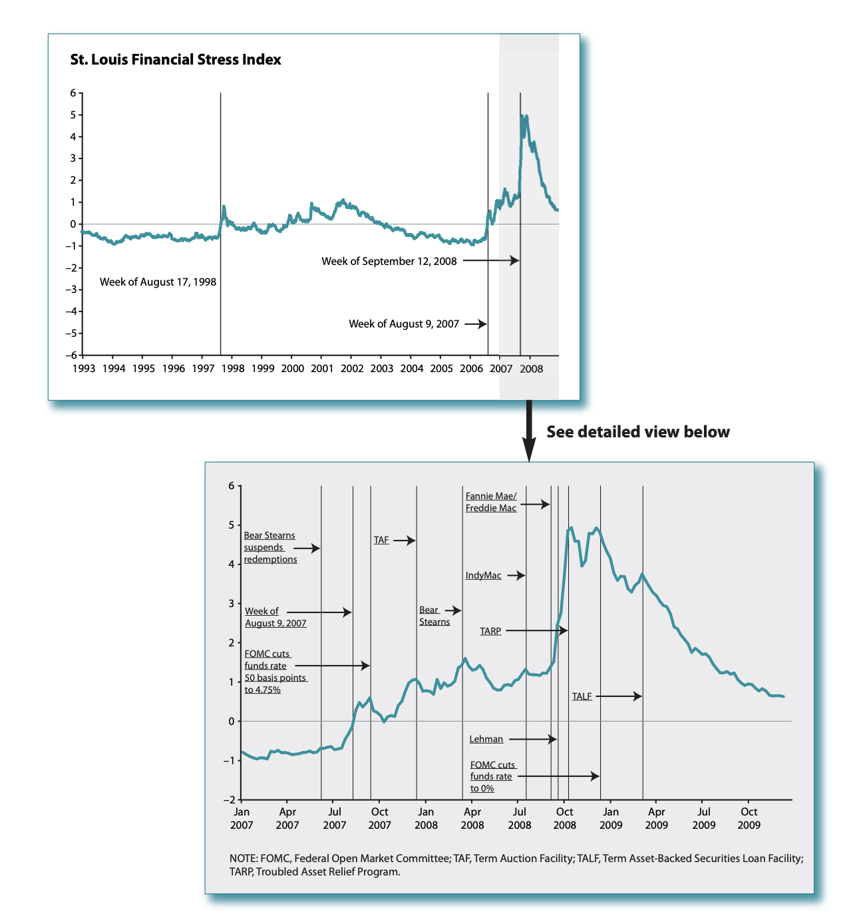

Figure: Posted on January 15, 2010

Views expressed do not necessarily reflect official positions of the Federal Reserve System.

### Aims and Objectives

 A: If we take the collectively the central bank to the point then a central bank’s main objective during a financial crisis is maintain the stability to the market and to contain the damage from the crisis and for the limit the impact to take the essential step for it which has been impact on the real economy. the first its compulsory to stable and restore position in calm for the financial markets. Market panics and instability caused the reason and create the equivalent of a financial heart attack by cutting off the availability of credit even to those institutes whose were in the good shape and healthy institutions. This increase the damage in the financial system and is one of the main transmission channels through which a panic affects the real economy. therefore, the central bank only has the option to reduce uncertainty, to ensure that the market must perform properly for short-term credit.

### A brief description of the topic

A: The financial crisis of the year 2007–2008 was when the financial crisis was happened. The “worst financial crisis since the Great Depression of the early 1930s” in the time period between or middle of 2007 was the time when the US financial market went through a collapse in the market and went into the slide of worst financial crisis ever. In August 2007, losses from subprime loan investment got crashed and investments caused comes in the situation like panic that as resulted it affect the froze lending system. In 2008 the biggest finical company named Lehman Brothers collapsed and later this biggest U.S. company got bankruptcy. When the bubble burst of the financial crisis, financial institutions were left holding the huge amount of money which was estimated approximately trillions of dollars’ worth of near-worthless investments and illiquid assets in subprime mortgages. The capital conditions of the millionaire corporations (MNCs) are of particular interest, just because the condition of the world economy has changed, and now global investment is ruled by it and with business. this data was collected from the textbook on international financial management (Pattnaik, 2020).

What are the main policies to resolve banking crises?

A: There are two groups that can be used to cure the consequences and responsible for the spreading of the financial crisis. containment policies are the first which are responsible to stop and heap to fight with it, which are used before it happens when the stage of starting of the financial crisis. for the short term this is often characterized by damaging the sentiments on the viability of the financial system and the economic prospects (Bulletin, 2013). it is very difficult to say that crisis is showing only the stability of the liquidity or solvency problems just because of it may involvement of run-on banks, the total business market, and involvement of the domestic currency as well. for the requirement of more time to determine what are the reason and policies need for the crisis and what is the nature of the crisis, then the government decides to resort to policies, and one is, to make provisions to the banks for the emergency liquidity, other financial intermediaries, such as commercial banks, investment banks and some of the mutual funds, etc.

# Chapter One – Literature Review I

The main purpose of this topic is to select a review of the theory about economics and the financial crisis, reform and update the implementation in the previous financial policy, the financial policy takes the position and implemented in the market when and the relationship comes between financial crises and update and reform. The objective of this review is to highlight some research which implement in the market and certain findings that may help us and easy to understand the relationship between financial or economic crises and financial policy reform.

After the 2008-2009 GFC, there was more support from the economists and the government due to the inflation, and policy maker made a huge impact and support for the macroprudential policies and capital control measures system implement and uses for the safety, the safety for the improve about to intermediate international capital flows, the main reason for improving that because it may cause and become a major role in it and address their related points and requirement what kind of risk and identify the risk to the financial systems. IMF and BIS are the other international organizations that are designed to help with these kinds of crises and many empirical studies which is work to study the macroprudential policies, and their job to study and explore the relationship among them. And those studies are capital controls, financial stability, and international capital flows. As noted, that according to the IMF in the years of 2011,2012, to support the financial system and to support sustainability the MPMs are required for that. and uses the capital flow management also, Capital flow management measures (CFMs) work is to rectify and limit of capital flows and help to measure it as well, comprising residency based CFMs and other CFMs.

Therefore, the main object of these topics is and the main point that who were the main object and what firm who were responsible for this crisis on the other hand we will question and look for the solution and answer the critical questions as well as find out the blamed one and later we will find out who was involved in this crisis and the responsible parties and deals with the resulting effects as well. and what this crisis impact globally and will show the consequences for the economy of the US and the global economy. in this topic refers to the different findings regarding the research questions will be discussed with deep analysis based on the research thesis where the accurate facts will be concluded and recommendations. researcher and an expert financial economist Eichengreen (1987), there are aspects that come in the financial crisis it was said the impact will also affect the financial market which can be defined as a disturbance to financial markets, insolvency among debtors and intermediaries, and associated falling asset prices. which is by the financial system it will be spread, for allocating capital through the disrupting the market’s capacity. This statement by Mishkin (1991), who stated that financial markets are not stable or not in the condition to provide the funds in the market for the investors and the main reason behind it and a major factor was the financial crisis which is create the disruption. and the condition will be worst because of the hazard problem and then as a result most central banks to play their role just because other banks push this situation to lenders of last resort. According to them, the reason for the crashing of banking crises and stock market fluctuation, and speculative bubbles situations are related to it. not only those countries which were developed and whose emerging economies faced huge challenges and experienced the financial crisis. in since 1980s end the UK and the Nordic countries faced the crisis on a large scale till Japan included in the early 1980s (Eigner, 2015)‘Rip and Down’ situations in the financial market were faced many times since 1929 due to the occurrence of major economic crisis or in financial crisis as well. in 2008 the world faced the biggest financial crisis ever been done in the global financial market. after the crisis happened, the world couldn't get recover for several years and done a massive and huge impact on the economy in a major number of countries as well the condition of the major number of investors was still fear of investing in the market. for this reason, from the point of view of great researchers and financial experts, financial crises and downfall were successful to get in the position when the market fluctuates their quality, resolving the issue because the study said the economic collapse when the financial market gets disturbed and goes upside down falls, and the investors started the reason behind the crisis and what was the failure behind it and it impact on the economic growth as well and start working on development to make sure never happened again. just because of the instability of unregulated financial transactions and American subprime allocation spreading the crisis worldwide. it was all done just because of the instability of unregulated financial transactions done by the suited states of America by subprime allocation and spread the crisis across the world. It is said that that crisis was the worst financial crisis ever happened in history since the Great Depression of the 1930s (Eigner, 2015) and the GDP recorded around a 2 percent decline according to the data which was per capita in 2009 (Claessens, 2013) Subsequently, from the end of 2009 to 2012 in the European Union, there was an impact occurred terms of the European debt crisis, and the reason was significant adverse in international trade and the global economy as well. there are some the other areas which were suffered from the lingering effects of the financial crisis. and it was recorded that per capita GDP was still below the comparison what was in between 2008-2009 (Calvo, 2000). when the financial crisis happened it was estimated that the financial crisis led to the worst economic collapse and claimed that it stop the growth in the stock market and it happened since after the Great Depression. Most people blame it because it happened and claimed that the main reason for this crisis was the housing bubble burst and the financial crisis on a complex series of events in between 2007. the liquidity problem happened because it was because of The housing collapse generated widespread which fueled a precipitous decline and put a major impact on the stock market (NPR, 2009). By the time period of early 2012, according to the data, the US Economy starting and ready to spreads its wings and the Economy recovered somewhat but it was not in the proper condition as well and it was still fragile. and on the other hand, some other countries like Greece, Italy, and other European nations start to threaten the world to start recession again, and in Greece, Italy, and other European nations threatened to plunge the world economies again. Papers are a more suitable and more effective way to start the investigation and be accepted in this special issue investigate in a more deep way as well, to find out the way to improve the financial situation and put more effort for find out a suitable alternative for that and give suggestions on that. By the summer, of 2012, the ratio of the economic recovery decreased unemployment to 8.1%, but by the numbers, it got still well above full employment but needs to be in improvement. The recovery happened in a slow way but make a huge impact on the economy as well, and continues sluggishly, with increasing concerns over the stability of the Eurozone causing market volatility. Economists continue to improve their work and they also put more effectively and continue their upbeat, although more stainability and cautionary, rhetoric regarding recovery and the housing freefall bottomed out. in the stock market way, it got covered in a positive manner and recovered much of its losses, although in the market wild swings still were in the market price suggest concerns still exist. propose solutions to improvement for the solution and reduce the effects of the crisis, The Levin and Coburn (2011) in the report it was generated by the US Senate concluded, “the financial crisis was not a natural disaster, but the result of high risk, complex financial products; undisclosed conflicts of interest; and the failure of regulators, the credit rating agencies, and the market itself to rein in the excesses of Wall Street”. it make a huge impact on business failure, raised the ratios of unemployment all over the US, and happened because it spreads so quickly in the world after the US economy got in a weak position.

there are many causes were impacted on the different country’s economy and different types of effects of the financial crisis on the world economy The “worst financial crisis since the Great Depression of the early 1930s” in the time period between or middle of 2007 was the time when the US financial market went through a collapse in the market and went into the slide of worst financial crisis ever (Thakor, 2015). One metric that gives a sense and helps with the involvement to determine the current financial crisis is the scale of the financial losses involved. according to the financial data of IMF’s latest Global Financial Stability Report (IMF, 2008) , (Xafa, 2010)the total and approximate estimated losses on U.S.-based mortgage-related and the total of 1.4 trillion dollars credited will add up. according to the middle of the month of September and based on market prices.

In addition, in order to determine the major role of globalization that shows how the global financial crisis spread, first of all, we need to know what the main reasons are and should have understood the reason behind the global financial crisis, and the extent of the impact that how the market all of the sudden faces those issues and market got to collapse. For this reason, Before the last financial crisis, it seems that we need to have knowledge about the financial crisis because it could have happened in any other country as well and a change of policies so that the next time country could be more alert and could be saved from the negative effects of a financial collapse. the critic's literature will review the different aspects and examine them, the data will be followed by the research methodology chapter. this is like making the situation after the war and putting a huge impact on the economy such losses would be the most extensive experienced in dollar terms. Moreover, seeing in the month of mid-September the impact on the global market and at the end of it was estimated it would be more chance that will extend by time as well.

the data of the index—available till the month of September 2008 and covering the different types of variables such as interbank spreads and equity and bond market performance— the stress is reached the. on the peak periods across the range of different countries if it is comparable to the previous peak period. the most stressful about it is that the stress level is already at the peak period of all time within the year it affects the countries as well which was mentioned in the graph (see Chart 2). and, since after the month of September, the strains level is already on the peak and has spread dramatically day by day to emerging economies, including many of those countries which were initially seen as being more resilient and stronger in the economy to external factors than in the past because that was happened with strong in the market and with the strengthened balance sheets and huge international reserves. It is said that the economy was erupted more than two years during the period of financial crisis. the reports claim that after the years of the financial crisis held the effect still emerges hit by the recession. In the period of 2008 when the financial crisis slowed the economy and dramatically became huge and intensified in the market it happened when the fall of Lehman and the rescue of insurance giant AIG, happened in the period of September 2008 (Xafa, 2010).

## Covid-19 Crisis

At the time when the disease coronavirus COVID-19 advent it spread so fast, within a few months the world health organization declared a global health emergency in approximately all countries, which affect all the land and including those countries which were most developed and moving for the developed as well (Silva, 2020). mid-July month of 2020, the data showed the assumption was the end of the pandemic and then again, the second wave was reported officially, the data showed in early November 2020, it comes again in the second wave, but the officials said that the wave effect was not that much like on its first wave, it was low-intensity wave recorded in mid- December. In the mid-March 2021, the third wave was recorded and affected the countries again but the in a positive way the intensity was lowest in comparison to the initial two waves. around 20% which is in percentage numbers exhibited the highest positivity rate, Then the situation comes under control, and day by day the improvement was shown in the recovery gradually and under restrictions. the total number of territories was 220, regions and countries where the pandemic coronavirus (COVID-19) was affected. Conversely, then the advisory came from WHO will support and help with initial help and declare that initiated protective measures for the mental support and included psychological and take initiative and implement the plan to combat with pandemic (Geng, 2021).

In Figure 1, describe for when the virus transmits in the body and effect oral and respiratory mucous membrane cells through the respiratory droplets (Funk, 2020) Moreover, there are the most important and required three main protein surface (N) nucleocapsid protein (made with the reaction of capsid together with the nucleic acids of a virus) it possesses with the single-stranded RNA acid name of genome enfolded. those three are the enveloped (E), (M) called for the membrane and last known by spike, which shows that the into the lower airways and which reason behind to make a cause for severe pneumonia (Funk, 2020).

Covid-19 Crisis

The huge number of adverse effects in the world basically on individuals, and the economy of the country as well as the quality of life along with the health sector and mental health were the factors where the people suffered the most (Mann, 2020). Wuhan (Hubei region, China) is the place where the first patient appears, and the first infection also was recorded too, and the source says the pandemic appeared was also in the same place at the end of November 2019. after that WHO declared a global health emergency and then on going the total number of territories reached 220, and countries where the pandemic coronavirus (COVID-19) was affected. as a result, 174.117 million people got affected by the coronavirus, and the death count was recorded at 3.75 million, on the other hand, the number of recovery people's rate was also gradually raised and 157.157 million of the affected case went home safely after the recovery as of 7th of June 2021 (Liu, 2020). in the 21st of the century again a massive and mass number of people's death recorded approx. 3.7 million by COVID-19 to date, the mass destruction in most countries' economies and health sector got failed to recover and still going on come to reality, according to the WHO report the millions of number death case showing the effect on humanity which is directly affected the economy, This present study includes the health challenges and global economic crisis primarily emphasizes seeking COVID-19. due to the virus, continuing to hit the global health sector and mainly hit the global economy adversely. in south Asia, the third highest positivity ratio got found in Pakistan which is the 5th most populated nation and recorded immense cases there. with a death toll count around of 21,450 and according to the WHO worldwide with 29th number of most in various cases or the most COVID-19 positive cases with 933,750 (Dhahri, 2020) according to the data the month on June 6th, 2021, the first wave of COVID-19 got appeared at the end of May 2020. data says in the month of June the wave got take its massive spread and it was at its peak. Which however later on made a massive impact on economic growth and human living and the environment. at the time of 11th July 2020, India faced the 3rd number of infected people in the world with 2,922,58 active cases and a recorded number of 5,34,620 patients who were cured and discharged with a recovery rate of 60.86%. and then later on November 5, 2020, from official data of COVID-19 CSC data, JHU the total number of cases was found 8,411,034 with a total number of people died around 125,029 and a huge number of data recover with 7,764,763 cases (Ghosh, 2020).

and this part and the following, we will discuss the main cause of the crisis and about the crisis from the Covid 19 as well as later on consensus and the other effects on our point of view about the question of guilt in this sense. according to the different reports and the different aspects from the economists, there are many explanations and what was the main cause of the financial crisis and the covid-19 as well.

# Chapter Two – Literature review II

## Financial crises and financial policy reform

Financial crises can damage the economy and be difficult to recover. For this reason, it is said that they can remain in the market for long-lasting recessions. and can have a huge impact on us and damage macroeconomic conditions or sometimes the result can be massively destructive. and it would be necessary to reform the financial sector to change its policies to avoid the coming such crisis. It is widely recognised that before such challenges to act on financial restructuring measures and needed to reform policies and also financial institutions as well before it could be hit again at the global level. when it comes to avoiding such crises, we need to reform it because there should be a solid relationship between financial crises and financial policies and can be reformed at any time when it is most needed the most. In other words, when it comes to reform, it is said that the crisis is a provocation to reform the hypothesis and prevent from crisis to show the hypothesis (Drazen, 2011). A large body of literature is always made decisions and changing policies to cover the loss from crisis and discusses the relationships which can be easy to implement recession for crises and policy reform. Historically, the data shows that many countries experienced financial and economic crises in their time and then change their policies and implement them and regulatory responses to these crises and supporting the view that will help to an improvement from the damage happened by the crisis (Lora, 2004). In 1996, Mr. Rodrik notice that one nation facing the same issue, and their policy not working and not covering the damage from the crisis because the policy was totally falling the government decided to change their policies and agree on to reform them because of the policies were unsuccessful to resolve the problems. but according to Bates and Krueger (1993) were said there well economic condition there will not need to be changed and when the economic conditions are destroyed or when new a government come to rule the country then it happens mostly. Asatryan et al. (2017) were also shown their argument openly and gave statements that financial and economic is a strong catalyst for reform after strong catalysts existence come to limits then it’s hard to implement new policies and hard to implement to reform them. In general, reforms lead to that position where the possibility of an uncertain outcome, which could be encouraged to maintain the status quo then it will be very difficult to implement the policy to reform (Fernandez, 1991). there is also one explanation for crisis-begets-reform that it creates powerful vested interest groups when it comes to a successful economy creates. which may be included by those factors whose were not much needed for the reform, like bureaucratic red tape, etc. these parties only can just small reform but on a major scale they can't help to recover the economy for reform them which needed the most important. to weaken their influence on them and destroy their interest something should be happened to recall those respect which need the most. like, it can be severe economic deterioration on a large scale (Nelson, 1990). Moreover, there were two experts’ economists Tornell (1998) and Drazen (2000) who describe their arguments that in between an economic crisis can be among different interest groups may make a situation like where it increases the likelihood of reform. Recently, after many studies, it come to the conclusion that it can be possible to find out the relation after empirical studies of the data from the financial crisis and between dimensions of financial policy reform using likewise it discussed before subsections. our analysis confirms that in the meantime of economic emergency the crisis-beget-reform argument is not just in the policies but also in the context of financial liberalization. The financial economy has been experiencing for several years different financial collapses such as the Asian financial crisis in 1997, the Great Depression in 1933, and Europe's debt crisis. However, the most severe financial crisis was the financial crisis of 2007 which has severe consequences for several years. One of the major consequences was the unemployment rate which has been increased dramatically from 2008 to 2010. Some important changes in the allocation of mortgages and credit, GDP, or interest rates were also among the consequences related to the financial crisis. These changes pushed policymakers to review and change the different policies and regulations. The impact of the financial crisis was so huge that there has been several research about this topic in order to understand the causes and prevent a new occurrence. In fact, the Federal Reserve charged the Financial Inquiry Commission has been created in 2009 by the American government in order to investigate the causes of the financial crisis and understand how the central bank failed in the resolution of the crisis. One of their conclusions was the fact that the world economy has Sways been experiencing deregulations largely due to the instability of the financial system. According to severe economists, deregulation was a real problem because, for the last twenty years, it allowed banks and other financial institutions to take major risks resulting in insolvency and a failure to regulate mortgages. In addition, based on the repercussions of the global financial crisis, many researchers agree on the fact that asset price and the increase of credit supply have been one of the major causes of the financial crisis of 2007-2008 because they initiate many issues. To go for any solution or conclusion we can say there were so many companies and that several parties have been involved because of their policies and as resulted in its push to trigger a financial crisis and still, if we go with the data, it is still highly complex and hard to mention to answer the main reason for the crisis and it’s hard to the question of accountability in this sense. What we know is that due to their wrong policies and wrong assumption these banks, institutions, and people created a crisis, and after that the cost tens of millions of people who were doing their daily jobs and their savings, their jobs, and their homes. to save the economy of the US they spent more than 700 billion dollars on the banking system because, after their wrong decisions and wrong policies, they lost more than trillions of od dollars of wealth and ruined the market's financial situation and the stock market was collapsed as well as resulted. As there were so many countries involved in that matter who caused the problem and those players involved from all over the world, the economic crisis brought made a huge impact on the rest of the work like many other countries to the edge of insolvency. Like for example there was a country name Iceland, whose three largest banks, the government decided to privatize them because they were heading for bank corrupt and collapsed as their liabilities were raised more than ten times higher than the total their country’s annual economic output it happened during the financial crisis. they were so corrupt and leaving the country as well and leaving their firms with hands full of money and no one taking the responsibility for it and seeing himself accountable. In the end, it is as always: the poorest pay the most.

A literature review on SMEs and their survival during the financial crisis presented some challenges. First, the financial crisis was not long ago, and thus in-depth research on the impact of the crisis on SMEs is not readily available. After consulting with several faculty members and a librarian at the Dublin Business School, the researcher decided to draw primarily on the opinions of the major Irish financial institutions, the Central Bank of Ireland, the Irish government, the Irish Small & Medium Enterprises Association (ISME), Chambers Ireland, the Irish Business and Employers Confederation (IBEC), the Small Firms

Association (SFA), Economic and Social Research Institute (ESRI), and a number of other institutions that provided research relevant to this study. In addition, the researcher used surveys, newspapers, online publications, academic journals, and documents produced by the above institutions to incorporate the most current data possible into the study. A complete list of sources used in this study can be found in research.

The importance of SMEs to the Irish economy is evident from figures published by the Central Statistics Office (CSO) of Ireland in 2011. According to the report, it was estimated that on that current period there were more than 189,000 active small and large numbers of businesses in Ireland, of which more than 99.8% were SMEs. Interestingly, the same report found that nearly seven out of ten people in the business economy are employed in SMEs and that SMEs account for half of the turnover in the business economy (EUR163.5 billion for SMEs compared to EUR162.7 billion for large companies). This shows that SMEs in Ireland Ireland make an important contribution to employment and also to tax revenues in Ireland. The Office of Revenue Commissioners of Ireland confirmed this in a 2013 report, which recognised that SMEs create the majority of jobs in the economy. In the same report, the Office of Revenue Commissioners characterised the SME sector as indigenous, employment-intensive, non-export service businesses.

As a sector, the role of SMEs is most important to grow the capital in the market and as well also responsible for the heavily reliant on GDP and domestic demand (Revenue, 2013, p. 18). Prospects for SMEs are more reliable and more trustworthy for the grow the economy and SMEs are more closely linked to the domestic if we compare to the other large 17 larger firms (Lawless, 2013).

This statement by Mishkin (1991), who stated that financial markets are not stable or not in the condition to provide the funds in the market for the investors and the main reason behind it and a major factor was the financial crisis which is create the disruption. and the condition will be worst because of the hazard problem and then as a result most central banks to play their role just because other banks push this situation to lenders of last resort. According to them, the reason for the crashing of banking crises and stock market fluctuation, and speculative bubbles situations are related to it. not only those countries which were developed and whose emerging economies faced huge challenges and experienced the financial crisis. in since 1980s end the UK and the Nordic countries faced the crisis on a large scale till Japan included in the early 1980s (Eigner, 2015)‘Rip and Down’ situations in the financial market were faced many times since 1929 due to the occurrence of major economic crisis or in financial crisis as well. in 2008 the world faced the biggest financial crisis ever been done in the global financial market. after the crisis happened, the world couldn't get recover for several years and done a massive and huge impact on the economy in a major number of countries as well the condition of the major number of investors was still fear of investing in the market. for this reason, from the point of view of great researchers and financial experts, financial crises and downfall were successful to get in the position when the market fluctuates their quality, resolving the issue because the study said the economic collapse when the financial market gets disturbed and goes upside down falls, and the investors started the reason behind the crisis and what was the failure behind it and it impact on the economic growth as well and start working on development to make sure never happened again. just because of the instability of unregulated financial transactions and American subprime allocation spreading the crisis worldwide. In those times the Irish Minister is known as Mr. John Perry T.D., and between the time period 2011 and 2014, he emphasized how important the SMEs are for the economy and how they could help Ireland to be sustainable jobs in the market. and how evolutive the platform for creating sustainable jobs, which could help to boost the economy of Ireland as well as will bring Ireland back to Ireland on the map for economic growth. this statement cleared that if in Europe the 23 million SMEs will give a chance to extra one employee the problem of the unemployment crisis will be no more. this data shows the how importance of SMEs for both employment retainers and employment generators. (Department of Jobs, Enterprise and Innovation, 2014). This underlines the importance of SMEs both as employment retainers and employment producers.

### Gap in the Literature

The financial crisis was triggered by falling housing prices in the United States and the increasing number of borrowers who were unable to repay their loans. Home prices in the United States peaked in mid-2006, coinciding with a rapidly increasing supply of newly built homes in some areas.

# Chapter Three – Methodology

## Data description and sources:

The approach we have used to combine the various sources and research to complete the literature review and research methodology is explained in detail and clarity in this chapter based on the sources and the researcher. Due to the availability of a huge number of sources and a wide range of sources on this topic, the researcher decided to do in the field of economics and in the field of finance. after a deep study and long research, this paper showed and made this conclusion about the World Bank's failure at the time when the economy got collapsed and determine the impact of the financial crisis as well for the world economy. especially in the United States, where investors and others trusted and invest their money and is also used as support for the literature review determining the main impact of the global economy and financial crisis on the world economy, after reading some of the conclusions we can make and rise some related to the following research questions, for the main objective for this paper and the main objective of this project is: research question: an economic and financial crisis in the United States and reason for the failure of the most trusted bank in the world such as central banks. First of all, it is necessary to outline the research question and previously set objectives and correct the sources and research material as the focus of our research work. The critical literature review in the last chapter was mentioned as the main support for the research methodology section.

In this chapter we will explain the different research and the sources that we used to collect our necessary data from the paper and data related to the description of economic indicators and collect all these data with research sources with useful material, then we will decide to apply in this dissertation. In addition, we will explain how we collected the different sources and different data to evaluate the impact of the financial crisis during the pre-crisis, the impact of the financial crisis during the crisis and the impact of the financial crisis after the crisis. Statistics on the financial assets of the largest banks are also shown to assess the extent to which some financial institutions have been deemed too large by researchers and economists such as Gianetti.M(2007). This view is also supported by the Financial Inquiry Commission (2010); after losing the main causes of the collapse, it explained how the four big banks (JP. Morgan Chase, Wells Fargo, Citibank and BE of America) were considered "too big to fail", leading to a lack of transparency in their balance sheets. over a 10-year period, we will discuss the various factors that are given by most and other various economic factors such as unemployment rate, demand, supply chain fluctuate also, interest rate, gross domestic product, demand rate and subprime mortgage allocation given over a 10-year period will be presented in the following section. in collecting data, we will never use the approach that we used to collect the necessary and required data and to conduct this research project. To accomplish this dissertation, we will explain how this information was obtained from various sources and how the necessary data for this dissertation was collected with the goal of answering our related and relevant questions. The questions and answers of our dissertation will focus on finding the appropriate and relevant solution for this topic that could fulfill the main objective of the thesis.

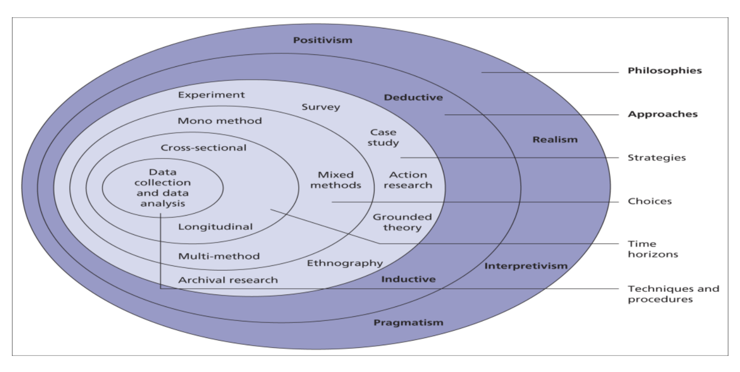

Figure: The research ‘onion’, Source: Saunders et al (2008).

By using the Saunders et al (2008) research "onion" model, by using this model provides insight knowledge, and consider as the most appropriate method of research philosophy, approach, use of strategy, choice, time horizons, and techniques and procedures. Each layer of this model is important. The analysis of each layer, ranging from the outer space to the space of the inner layers, allows to achieve the methodology position and also helps to determine the most appropriate research methodology to be used on each layer and in the final phase to collect valuable data from surveys.

### Research philosophy

The first layer of the "research onion" begins with the identification of the appropriate research philosophy, it is offers and proposing the four main philosophies: which are contain with Positivism, Realism, Interpretivism, and Pragmatism. According to Riley et al. (2006, p. 17), both positivism and interpretivism are based on a common desire to understand behavior: "It is the case that interpretive researchers can never be absolutely certain that they have grasped the 'worldview' of the people they are studying, nor that they are correct or uniquely validly interpreting the meaning they encounter." Positivism seeks to apply scientific research methods and test hypotheses based on existing theories, usually using quantitative methods. Interpretivism assumes multiple realities. Realism assumes real entities that are independent of human perception.

In discussing all of the above research philosophies, it was felt that the positions were not in favor of applying realism, positivism, or pragmatism because the current financial crisis is relatively new and ongoing. There could be a complex combination of methods and tools used by those who have the those which businesses with revenues, have assets, or certain numbers of employees below a certain threshold (SMEs) that are not based on a scientific approach or theory. Therefore, the most appropriate research philosophy is interpretivism.

#### Research approach

The research approach, when we talked about it is said to be concerned with the application of theory. Saunders et al. (2007) distinguish between the deductive and inductive approaches, both of which belong to the research approaches. The application of the deductive approach is a progression of theory and speculation and modifies a research strategy to test the hypothesis. Inductive research "involves the search for pattern from observation and the development of explanations - theories - for those patterns through a series of hypotheses," and it involves selecting data and developing a theory in light of the consequences of analyzing the data.

As shown in Figure 2, research involves the two main principles known as a quest in the explanatory sciences and the other principle known for research in the design sciences. The research process includes three phases that belong to explanatory sciences, and the main purpose of these phases is to develop valid information to describe the state of the current social world or even to predict the current state of the social world (Van Aken, 2005). According to Vaishnavi and Kuechler (2004), all work that begins with problem awareness starts with "improvement research', also known as design research, which focuses on problem-solving and also helps to improve the performance of an activity.

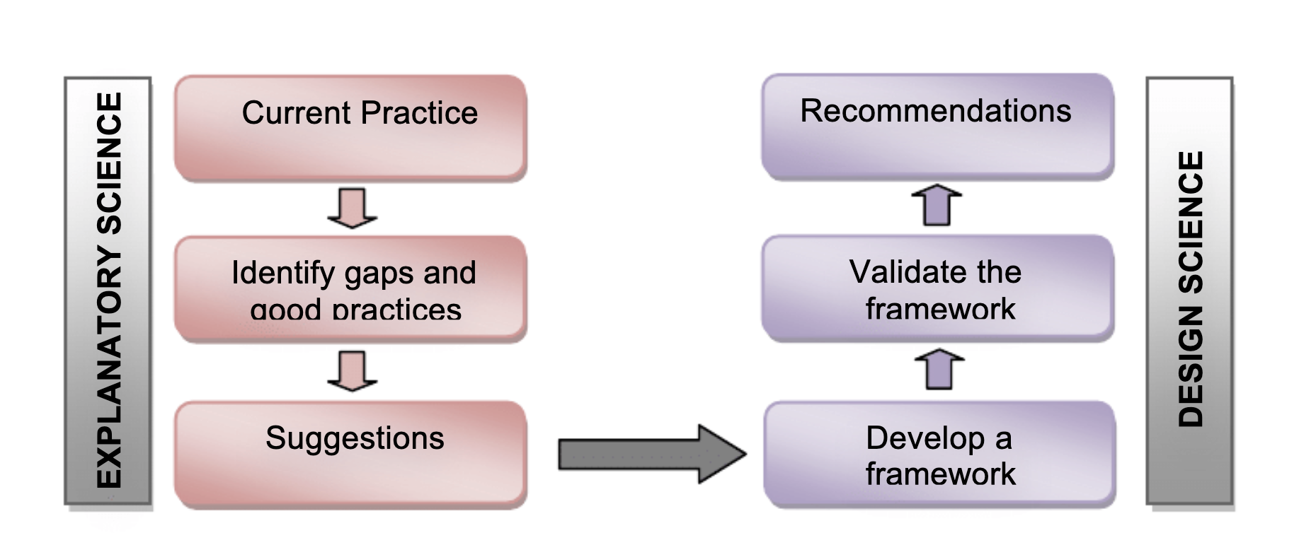

Figure 2: Research process

Research strategies

#### Research strategies

There are many types of research strategies such as experiments, surveys, action research, case study, grounded theory, ethnography, and archival research. The research strategy of the experiment is known to be unsuitable for the study of the study because the researcher cannot monitor and has no control over the phenomenon under study. The experimental studies could investigate the connection in between more than two variables (Saunders, 2009). There are always tries to misrepresent independent variables to study the effects on the dependent variables (Collis, 2003), which is not very feasible under the circumstances in this scenario. Therefore, such strategies and on the other hand surveys are also not allied with this research, so the typical use of survey strategy is in deductive research (Saunders, 2009) and positivist studies (Collis, 2003).

Research strategie

Research strategies

Research strategi

Some of the researchers blame mortgage lenders, policymakers, the government, or lenders. This is because they're gaming the system on a large scale and for their personal needs and are responsible for creating these problems. After all, lenders also made huge amounts of money during the recession by selling policies and products at high-interest rates to people with poor credit ratings and a high risk of default. 7 Here's why.

It was noted that at the time of the crisis, U.S. gross domestic product plummeted very sharply, and the entire market collapsed. Officials said that GDP fell by 4.3 percent.

Methodology for the Covid 19 pandemic

Bibliometric analysis is a process in which we can talk about the expedient approach to sift through the resources and study the development of research areas, but aspects such as the inclusion of topics and authors should be taken into account and disciplines depend entirely on the social, intellectual and structural prediction and imagination (Donthu N. a., 2020). This type of technique is used only by developers and researchers and makes an assumption about their capacity and range of disciplines, such as ongoing planning and appropriate strategy with strategic management (Ferreira, 2016). social responsibility, which is used by companies (Bhattacharyya, 2020) and medicine (Liao, 2018). and companies' universities (Singh, 2020).

Although, bibliometric studies have done the cause due to the pandemic COVID -19 in recent studies (Chahrour, 2020). It is said that each study has its own data and limitations (Chahrour, 2020). only PubMed and the World Health Organization (WHO) describe the most influential analyst and observational studies in the database and also describe the studies in the term therapeutic. in the scope of each area and the description for them have not studied the intellectual structure. The bibliometric analysis is performed and described by (Park, 2020) of the database belonging only to PubMed and the medical aspect from the point of view of therapy (Hossain, 2020). The Web of Science (WoS) database publishes only the collected articles and concludes that only biological topics are dealt with by selected researchers, such as those dealing with genetics and epidemiology, and those dealing with zoology to take care of or treat zoonoses. Importantly, (Hossain, 2020) in the field of socioeconomic belongs to the Covid-19 pandemic importance and is necessary for expansion-related research pointed out. in previous work to get rid of the limitation, in this study COVID -19 and to understand the focus of business research to use the science mapping approach. in the view of science mapping to understand the extent of a topic with the bits of help from researchers, with the development and period it helps to understand it (Singh, 2020). To answer the question of the topic for this study, after careful investigation and research, we come to the conclusion and identified several research papers and articles published in the field of management and business. The publications Scopus and WoS, from the use of databases. in the science mapping approach, the existing literature from data collection is more crucial than that. because this determines the database of these articles. from that conclusions are revealed from the relevant (Singh, 2020). We choose EBSCO, and Google Scholar or compared to others in the field of economics in the field of management high-quality peer-reviewed and situated journals are their greater reach, we choose both Scopus and WoS databases for ensuring greater reach (Ferreira, 2016).

we can see the changes in the values as factors are added or there are some other changes are made to or removed from the equation (Anderson et.al., 2012). The purpose of the regression and the reason for it is to look statistically at how the crisis affected society and how the time zone of the crisis differed. and at what level it affected and damaged the CPI than other time periods in the data. solving the question between the two crises to compare the statistical values is an important part of the topic.

if we look at Sweden's situation, we see that Denmark is graphically close. Both countries, Sweden and Sweden, are governed equally. When the data were collected from both countries, we started to import them and redistribute them in Excel, and then these data were imported into the statistical program Stata, where selective numbers and regressions were made.

The data and the report show that growth in Sweden is increasing rapidly in the first months of 2020. Similarly, the reports show that the growth of CPI is rapidly increasing until the first year of 2022. According to the data, the cost-plus incentive fee (CPIF) develops in a different pattern when we compare it with CPI, and also develop differently from CPI. when the financial crisis began, the solution was only recorded that it decreased from about 2 to 1 point, and it was estimated between 2005 to 2008 the position above the record show increased. when we take data the position of the financial crisis was in decreased in stable contrast apart from the period between 2008 to 2009. when it was the position of CPIF and HICP increased gradually.

as the financial crisis gradually developed, the financial crisis in 2008 had a profound effect on the real estate market, as problems with evictions and foreclosures spread within a month. The stock market took a hit during this time and began to plummet, while in response major financial institutions and corporations collapsed and lost millions, inflation spiked, and employees lost their jobs. This, of course, led to widespread layoffs and prolonged periods of unemployment around the world. In August 2007, when the impact on the subprime loan investments begin to lose and got panic that froze the global credit system.

# Chapter Four – Findings / Analysis / Discussion

## Findings

Table 1, and Table 2 Related to when the pandemic got started COVID-19 and in other areas which are related to the business management provide some data from the sub-areas, all the information and descriptions about the synopses should also provide the correct information and with a solid basis for what research should be happening in this type of domain. In the business domain when the Covid-19 literature got expanded then it shows another different pattern, first of all, the Covid-19 pandemic related to the by expert's diversity of topics and sub-topics addressed has made an impact know about the future condition of life of various front. The main point to attract the scientist and the researcher is that when Covid-19 done a mass and massive impact on the economy and on the health, sector first attract to business and management were the two main factors to attract them, on the other hand, the area of diversity research was increase then some broad sub-topics were got raised in some important way. There was some aspect where the Covid-19 pandemic got affected the most and make the economy of the countries got stuck in the situation and hard to drive in a growth way, those core topic and factors were, the demand for goods and foods, affected the supply chain including domestic and international, innovation, transport in the three-domain like air, road or by cruise, service industry like in individual or public sector by government, and most important the employment as well, whose people whose manage their expenses their need doing by daily work or a medial class people cause the enormous pain and loss through the Covid-19 pandemic. by this studied showed that the Covid-19 gradually raised by the discourse way in the business area. and these core topics and research will also be healthful for the future upside or down because after this scale of health and financial economic challenges when we start to play a major role within a short time of period the help economy to run again, so these data and research will be helpful for the future challenges as well. By the bibliometric study explanations and research in the short period there were in approx. more than just four months it was recorded and by official data the published of the total number of research and unique documents were around 107 in Scopus and WoS and mentioned about the total number of journals were who published were 71, the number of different types of institutes was counted 272 in the total 61 countries in the world just for one crisis. this finding, the most active and known authors and sub-area of the research there was just related to the one topic no other than Covid-19 pandemic all the research just happened for Covid-19 because in a short period of time it causes the most and in a short period, some of the countries declared the breakdown and downfall after their economy. got exploded who’s not faced the challenges or were not capable to recover it from the pandemic. Thus, after the situation got under control and the economies start run from the affected area where Covid-19 impact the most then it the study and research helps identify potential from the knowledge in the field of those domain areas which were affected the business and management. In the different types of aspects and domains in society and business, the study said that Covid-19 will remain in society for the short and long term, using of bibliometric analysis in the field of business in Covid-19 by intellectual structure gained the perceptive insights. The findings of this study about the evaluative literature reviews on the pandemic and between the complement existing subjective. Every year reviewing the Scopus and WoS databases to ensure they maintain the high quality they have published them, the study from the bibliometric is only utilized to collect the data from the database, but when the other database is not found or hard to get, like Google Scholar, and other databases like PubMed, on the hand EBSCO, may be influenced or effect representation it. those databases are not covered more and updated by time period because securing these databases is really important to save them from falls and to avoid bias news because it could also affect the future study.

## Analysis

This chapter mentions the research and the findings is to conduct in order to explain the different effects of the global financial crisis which were happened in the USA on the international financial market. After a deep understanding and research of the causes and put the impact of the crisis, the major economic indicators like the gross domestic product also known as the GDP, when the financial crisis came of economies got collapse the unemployment rate, the credit growth, services, demand, and the allocation of mortgages happened. In fact, these economic indicators can be used as for future recovery and use as a reliable factor, and it done helps to serve as the foundation for the economy for the development of a country’s economy. We have been analyzing the different factors and indicators and the different data collected through the second research method in order to establish the different sectors affected by the global financial crisis, the researchers discovered that in each country there is the global phenomenon of globalization the great level of interdependence as resulted in that was happen. Mendoza (2009), based on two long research and with observations, the author suggests that financial globalization played a positive role in the financial crisis and also played an important role in the global financial crisis. Indeed, the fact in the United States of America has a large number of large amounts to growth in the United States with help of sources like by foreign borrowing leads that to think in debt position and help to recover from it like a surge in debt in the United States we be seen as different aspect and the consequence of financial globalization. In fact, Onyikwn (2009), some experts have a different opinion that an economic crisis has only happened when due to the contagion effect, which is the result of we can in the reports of official and the interdependence of financial systems. In order to assess these issues, we can see with the official data that US credit boom almost in doubled in position from 1982 to 2008 and was mostly financed and maintained by foreign lending

## Discussion

In between 2007-2008 the discourse provides and explained a brief discussion on the financial crisis. This discourse argues that in between what happened in term of financial crisis and explained the consequence of the latest ideology or incarnation of capitalism which is work for the prevalent under the new ideology and the services comes under the institution: Finance Capitalism. In between the 2007-2008 the total GDP of United State was affected approximately around 70 % according to the officials (Marazzi, 2011). according to the reports in between 2007-2008 the Financial Crisis just nothing a crisis but was also nothing short of a catastrophic shock. The crisis has made a huge slump in the history and one of the greatest ever since if we can look up the official reports according to the 1930s Great Depression (Smith, 2010). then the questions raised here and lead to that obviously to a series about of “how” and “why” the reason and raised questions. But the most disturbing of thing that raised the question that in the fray has something to do with the one more important and essential element of “when”: when will the same thing happen again? when there is no difference between capitalist to “hiccups” and crises (Kotz, 2009). the official says that the business fixed investment plummeted at the annual rate which was the around of 39.2 %; this is the data which was considered the after the second world war the fastest rate ever (Kotz, 2009), into the discussion we found that the small-scale crises that happened the most of time usually blamed made upon the usual business structure and cycle and demand to change the policies in it; however, and on the other hand, the big businesses are only matters of great interest. It was discussed and argued by (Kotz, 2009) that severe structural crises risen due to the institutional type of capitalism which was prevalent and continues implemented within the said historical period.

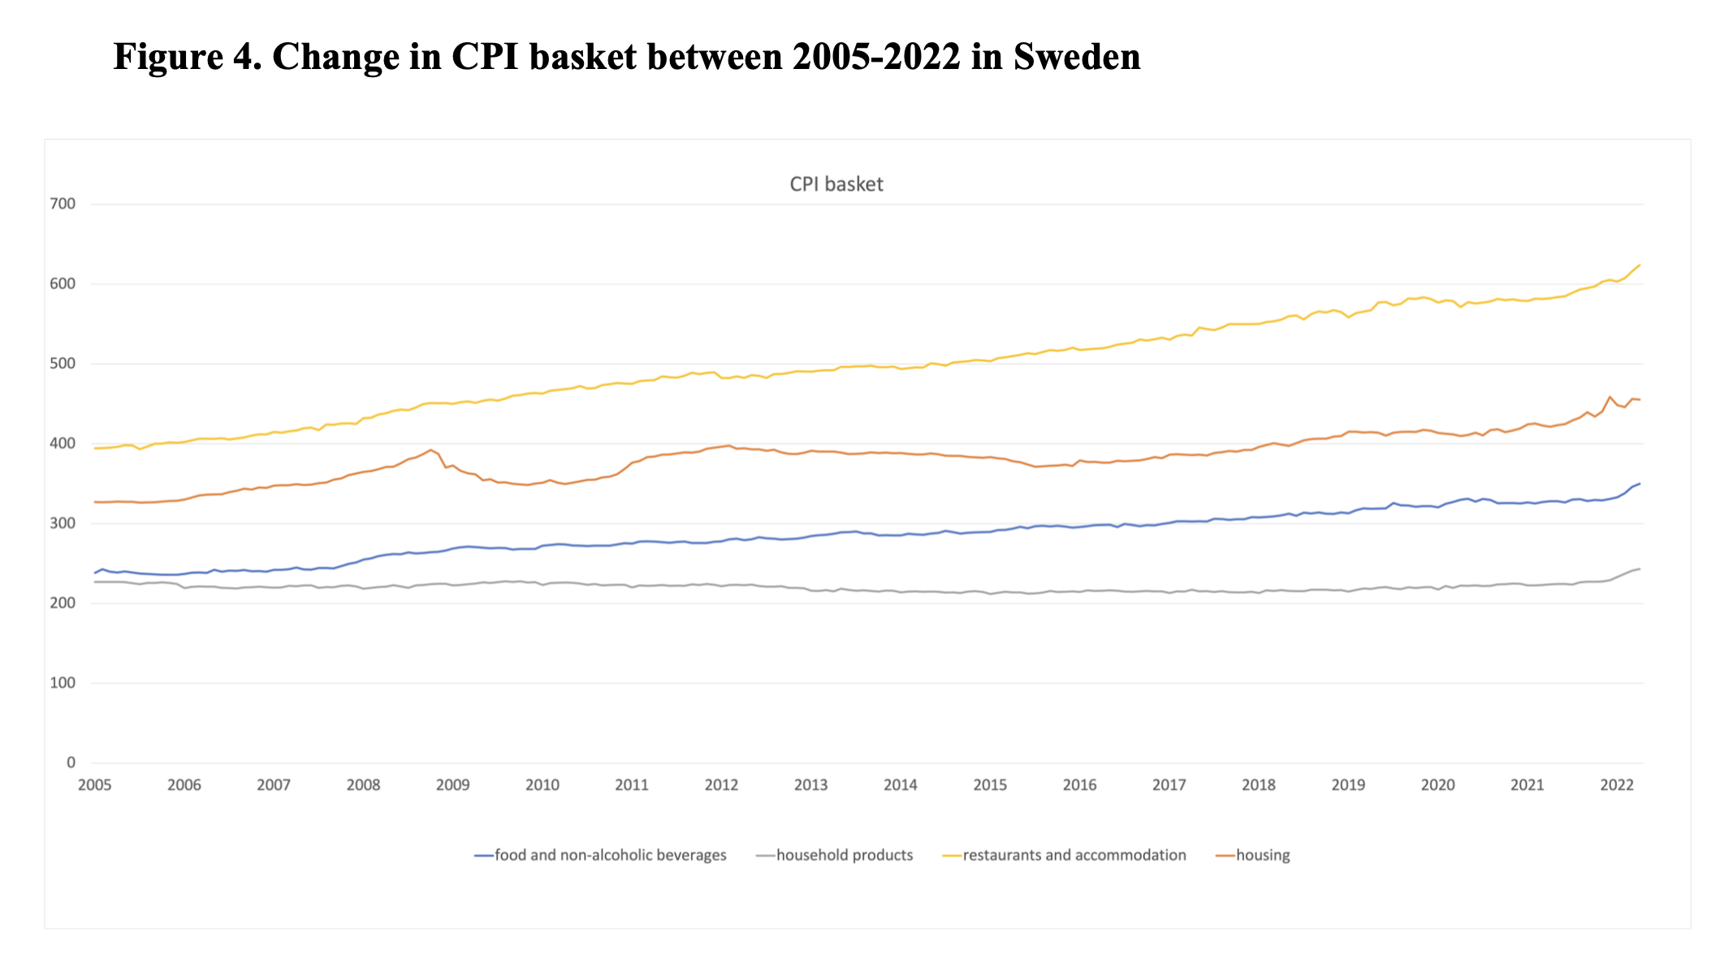

Figure 4. CPI growth Change, CPIF growth, and data from 2000 to 2022 HICP growth in Sweden.

Figure 1 shows how CPI growth (new_KPI), CPIF growth (new_KPIF), and HICP growth (new_HIKPSverige) have changed between 2000 and 2022 in Sweden. The first shaded area shows financial crisis (2007– 2010), and the second shaded area the pandemic (2019–2022).

In this figure shown that the four peaks where the two crises were happened and both were the were on the highest peaks, and according to the official and data it mentioned that pandemic is remarkably higher remarkably higher than during the financial crisis. In the period between 2007-2008 before the financial crisis, the growth was continuously raised until the 2007. At the period when the financial crisis was begun, the level of the CPI was at the lower point. and in the following years, the growth of CPI increased. Since before and after there are two peaks the financial crisis, the time period and peak time of financial crisis which was does not appear to be significant. The growth in Sweden about the Cpi was rapidly increased in the first few months in the year of 2020. As long as the financial data and reports was available, at the starting year of 2022 the CPI growth rose fast.

### Effects of the Global Financial Crisis on the unemployment rate

The secondary research role is to maintain and conducted to obtain data on the rate of unemployment in the United States it was obtained and recorded these data from the years 2006 to 2016. From the data above, we say that the early stage is when the world faces a huge impact on its economy and fights back-to-back to resolve an acceptable solution to the financial crisis that originates in the United States of America. already evidence there is mentioned in the government-generated official or in data in the critical literature review, during that period of economic crisis between 2006 and 2016, nothing happened significantly increase the unemployment rate.

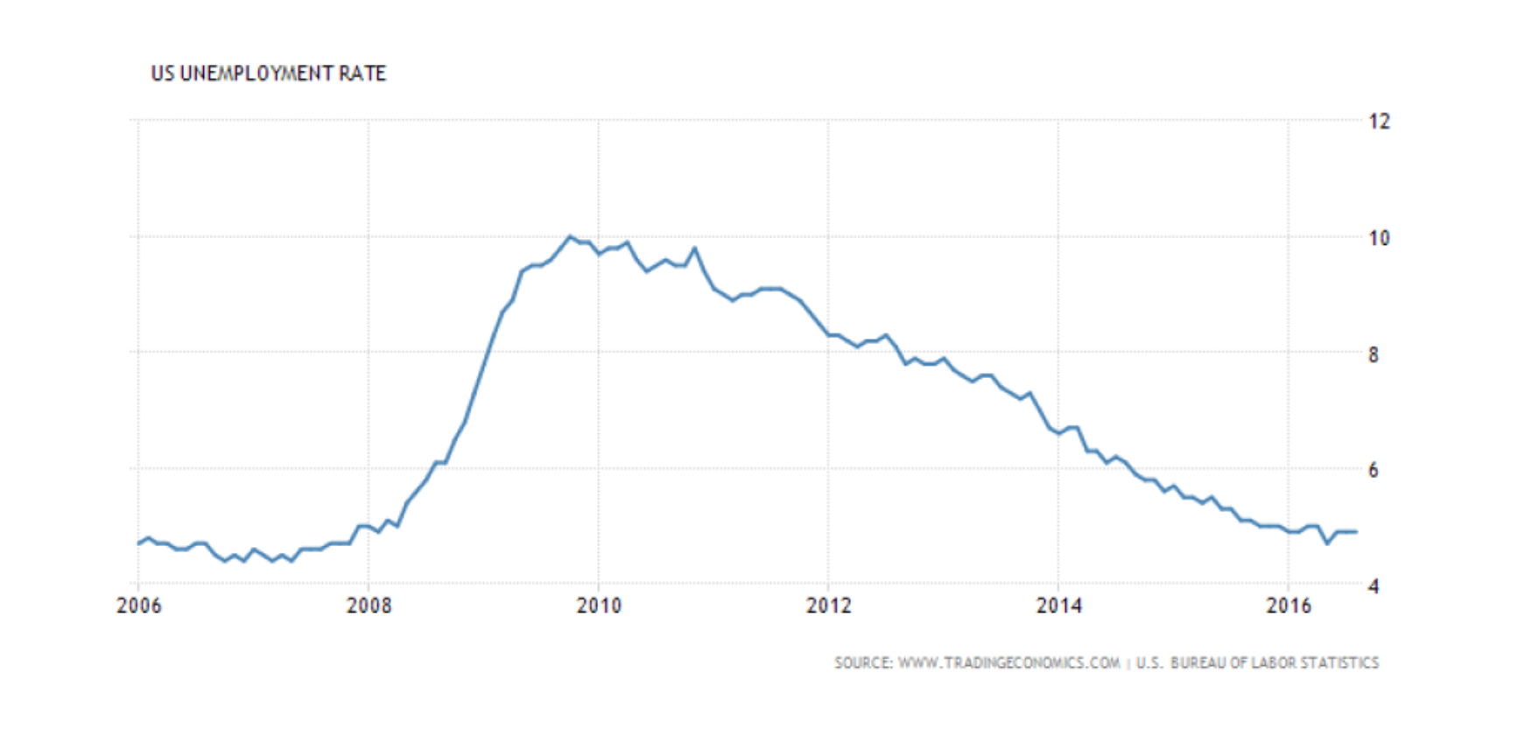

Table 2. US unemployment rate data

Source: [www.tradingeconomic.com](http://www.tradingeconomic.com) Bureau of labor statistics

On the graph above, is mentioned about the record of unemployment rate in between 2006 to 2008, the unemployment rate was relatively low and caused for many years and cause his impact for in the market. Howsoever, there is a piece of important information about unemployment which increase in 2008, following the beginning in every country who got sufferers from the crisis and faced the loss from it and in the global financial crisis of 2007-2008. In fact, the unemployment rate almost doubled when the inflation and crisis take you from the all-around and this is the record shows of the same period in the United States (from nearly 5% to 10%) from 2008 to 2011. When the market starts fully active After the recession and then the rate of the unemployment rate started to decline progressively from 2011 until now. We can see that the crisis was so epidemic in the graph in almost 5 to 6 years it took to recover the economy and from that moment the rate of unemployment get started to decline for the US economy to regain a low unemployment rate (approximatively equal to Sec).

### Inflation rate

Inflation is the rate that will increase when such over a period of time and typically is like a broad number and measurement when the people find hard necessary goods at a high price and also can be defined as the extent to the price of goods and daily basis service where the most number of people suffered and come from med-class or poor families also known as the CPI (BBC, 2014). In fact, inflation has the capacity to fluctuate the rate of interest also when interest rate borrowers must repay from their savings, assets, loans, and mortgages. Based on these different reasons, inflation can be considered one of the most important economic variables in the assessment of a country’s economy besides the interest rate and the gross domestic product. For this reason, the researcher decided to explore the inflation expectations in the United States, volatile enough to impact several countries during the economic crisis of 2007. In our different research, we can see that since the global financial crisis there were two factors one is liquidity and other is. Economies factor and can put disturbance inflation and they have that influence. One of the consequences a period of economic crisis and then making a huge impact on the global financial crisis can be shown by the negative inflation values. In fact, the decline in inflation rates, lead to price changes which turned into negative values pushing economists to think about steps in order to prevent deflation (Jeanne, 2009). This chapter attempts to determine the effects of the global financial crisis on inflation rates, especially in the United States. To see how the inflation rate didn’t meet the economist’s expectations, we will see how they differ from the central bank's objectives. In fact, if the inflation rate were well implemented, it shouldn’t be dependent on possible news and still be stable. The other use for the inflation surveys to measure the economic or financial effects of the global financial crisis, then we also use it inflation surveys.

### Impact on Big Four Banks

The global financial crisis reveals at the period there were some majors were too big, and to analyse them and study them in the short time the balance sheets and flow statements were so large that economists initiated the notion of “too big to fail”. It means that if these financial institutions failed, they could harm the financial system and turn down the financial system and the economy because of the lack of transparency of their balance sheet associated with deregulation. In this section, we focused on the biggest four worldwide bank chains, which also faced a huge impact on their financial situation those four banks are like the “Big Four” banks known as JP Morgan Chase, Bank of America, Citibank, and Wells Fargo. In fact, in the end, we will make points on these four banks' balance sheets as well. in 2008 biggest financial crisis despite ensuring the market should be more active and never recover from the downfall of performance, the central banks take come forward to take the necessary step for the financial crisis and decide to promote the major transactions in the biggest hits. This section provides a better understanding of the ‘too big to fail’ notion and should serve as a basis for the development of new reforms in order to prevent a new occurrence.

### Effects of the COVID-19

The COVID-19 pandemic leaves the world economy in the unprecedented decline stage which will have a huge impact in the upcoming years of recovery from it and a decline in global activity. developed and emerging countries faced a huge impact in a short time and merging economies the situation went worst after the crisis led the whole world into lockdown and large-scale disruptions in the developed countries and push into extraordinary speed and scale (Gopinath, 2020). For instance, as per the official record, the GDP of the global economy was recorded to decline by more than 4.9% in early 2020 just because of the Covid-19 pandemic disruption according to the IMF, the trade data recorded by a decline in trade, transport, and other goods was likely higher than ever before during the pandemic period crisis (IMF, 2020). Consequently, in the second quarter of 2020 global trade was affected the most by 3.48% due to the lockdown, and that caused the weak demand and effect on the. supplies well and disturb the transport and directly cause on the chain supply and the number of aggregate demands started being declined (Vidya, 2020). due to the steep income loss and weak consumers, the impact directly goes to the market economy and the market started to decline because of less consumption of goods and services was witnessed a marked. Similarly, by the reason of the reluctant impact of consumers to consume certain goods, transport, and services, and then is would be very hard to make again trust and confidence in the consumer (Eichenbaum, 2021). Firms were required to cut into the production for the sale because of the decline in demand and also affect the supply too as a result of uncertain future earnings. in the second quarter of 2020, the total number of full-time employees who lost their job was more than 300 million according to the officials and more than 130 million lost their job early in 2020 (IMF, 2020). when the data comes in decline in total aggregate it means the raised chances for inflation and suffering for the poor and mid-class people due to a raised price of daily usable goods, and oil price (IMF, 2020). according to the official data of The World Travel and Tourism Council (WTTC) was estimated that due to the pandemic, not just the supply and demand got affected but also a 25% decline in global travel during the pandemic.

The emerging economies countries faced a major outflow in the term of capital owing to the pandemic, then by this reason when investment got caused then on the opposite side the production also got affected as well during the pandemic of Covid-19 (BIS, Bank for International Settlements , 2019). During the COVID-19 pandemic, Russia and Saudi Arabia reduce their export to the oil market the price of the oil in the market gone raised day by day, officials’ data on March 8, 2020, the per barrel price was $ 31.05 raised again, and by April 30, 2020, the price per barrel was recorded at $ 19.23. Similarly, around the world, the situation of the stock market collapsed on February 25th. For instance, Wall Street witnessed a huge downfall in the stock market in 2020 of march, because of banned and after the lockdown from the United States of America shut down their international flights and declare an unchanged interest rate, then the investors. With due to lack of confidence. Conclusively, with that space of ongoing pandemic, the world economy got affected, and for this reason, consequences may it make a blasting situation around the world and considering the more fatalities.

TABLE 3. Logistic regression-random choose effect model data

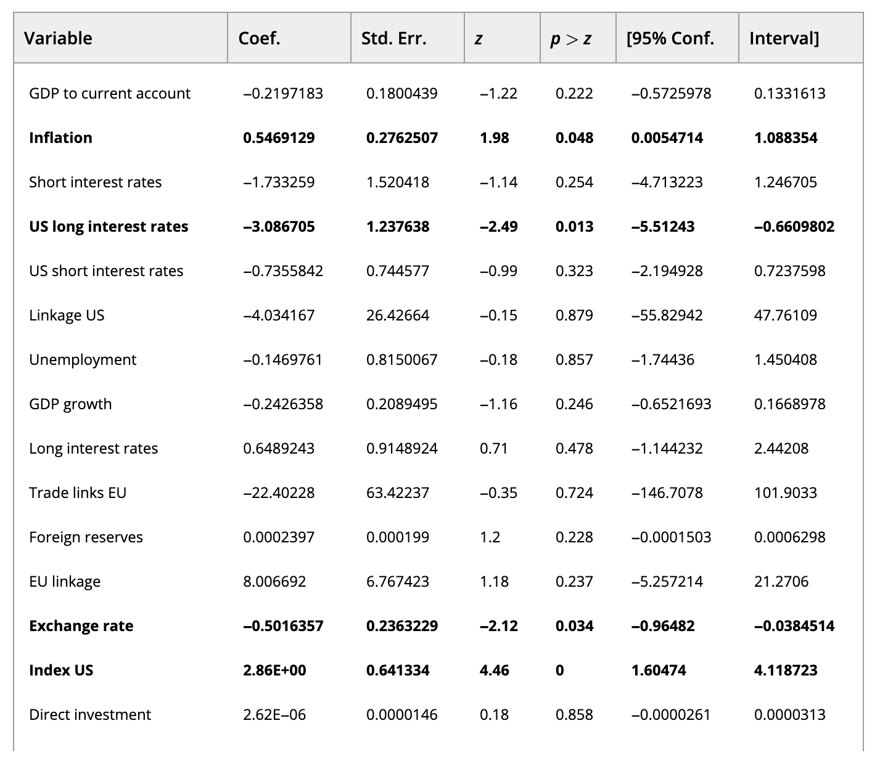

Table shows the outcome of logistic regression and describes that five variables are statistically important for that: inflation, US long-term interest rate, exchange rate, and what are the index US, and index EU as well. what is the Estimation outcome about that suggest that among macroeconomic vulnerability variables, for the explanation of two variables which are very important and statistically significant according to the crisis 2007-2008 and explaining the cause. there is one is known as inflation. Empirical outcome describes that if inflation will increase so there will be chances of a banking crisis, which is relevant to the literature findings (Detragiache, 1997); (Jacobs, 2003); (Kaminsky, 1998). The high inflation is the consequence of the economic boom, which is often happened and becomes a consequence before the banking crisis. During an economic crisis, in that situation, the demand is increased in terms of credit and financial investments which is make the bank more profitable than before. the collection of nonperforming loans or investments from the financial crisis period and risky credits may be led to a more dangerous position or in future banking crises as well. Additionally, when the inflation rate goes high as consequence it may put a negative impact on the world economy or in the banking sector. The inflation is associated with a rise in a bank' s cost because of an increase in the number of transactions (Demirgüç-Kunt, 1999). Inflation is included when the number of transactions will high with increase the bank's cost. when he global financial crisis rise between 2007-2008, the loan requirement is easy to contribute of loan requirement before when the low inflation rate and the interest rate goes up after the global financial crisis and inflation rate goes up and with debt burden and and it cause the problem for repayment the loan and rise bank's cost.

## Policy implications

Due to the major impact and consequences of the coronavirus, it has need to be put some urgent policies by the health sector, outsourcing, and businesses alike or it may support happen responses from the government. it is very important for global market distortions a properly designed policy is required and implemented before maximum distortions. a major role can be played, and implementation can be easy when the Governmental and industrial policymakers work together for short-, medium-, and long-term plans. the role of the government must be adaptable because the effect of the COVID-19 crisis can evolve by not taking a proper policy and delaying late implementation. The findings and propositions due to these kinds of this study based on data and demonstrate that governments should reform their policies as soon as possible in the existing economic policies to meet individuals’ requirements and provide them with immediate health, medicine, food, and other needs, in that short term the government must look up their interest, maintain political and economic stability; and cohesion should also be the priority in the scale. some effective propositions could help governments and other departments who make the policies to ensure in the future crisis by reevaluating rules and put some effective changes, changes in rules and regulations, it can also help of increasing their digital footprint, and look out the transportation and supply chain. The propositions could also help the business, social firms, and government agencies to identify the necessary and priority changes which could help to resolve the problem like, medical and economic issues, restore the department who could help in. services like educating people and encourage them, by trade, hospitality, and tourism. During the COVID-19 pandemic, there are a lot of factors helped to take the right session in a short period like big data(maximum number of people should go through the medical process of sign) and advanced analytics(which can be done by the business intelligence on a large scale, deep study and high quality of equipment should be the process) (Guo, 2021). Specifically, through real-time big-data-driven processes, can help the firm, individuals, or policymakers and help the researchers for the real outbreak of the pandemic and to understand what consequences or impact could be can harm the economy. At present the COVID-19 trackers are helping in different aspects which can be epidemiologists, the front-line worker, health workers, policymakers, or they can be scientists, because at some stage the scientists were capable to make the fighting drugs to the COVID-19 pandemic. and that helps to provide more information and take the right decision. by the help of a big data system the policy maker can easily find out the aggregating and synthesizing to resolve, control, and cure from it (Hancox-Li, 2020). Further, by the GPS data indicating people’s is disclose the activity of the people and their moments within some fixed or certain distance can we huge success full the government as well because government understand the population’s compliance whose are situated in the different places and help government for implementation on policy by social distancing mandates that are possible with only real-time analysis data which indicate through GPS (Chen, 2020). For example, companies and government departments can take the leveraging for their sources data which gathered from internal and external sources. like, the data can be the customer's activity history and record their moments, also information about the employees who are working in the frontline in the health sector, as well as others aspect were also usable examples of business operations monitoring and on other hand, for the sustainable development it is very important to social media should also know the importance about right information and to understand different scenarios during and after COVID-19. Reforms in policies like trade can also make a huge difference and make a large amount of impact on the COVID-19 pandemic because the implementation and also it will reduce the negative economic because of the necessary bits of help will get the countries in safe position and put the social impact of the virus, which could be helpful for the run the economy and with this effort, it can also help to build resilience and continue working toward the recovery from the loss. For instance, the reforms in the trade policy can also for beneficial for other aspects like those working under the public health transporters, public traders, and individual officials, by this implementation in the regulation the minimum interaction and easy to maintain the social distancing and make an impact on control the virus through it (Carnevale, 2020). Further, interventions in logistics operations are so important and they are also required the mitigate disruptions in the field of the operation and needed to continue the process and in the global value chain. The new labor policies or implemented policies should effectively be considered in terms of both aspects like, it could be made to fulfill the requirement of the demand of the situation and on the other hand, the policy could fulfill the supply for economic support and health protection measures (Carnevale, 2020).

# Conclusion

between the financial crisis of 2007-2008, the credit crunch or it also called as credit squeeze showed its effect and impact on production as well and started to transfer it and other services sectors. as result, it impacts on the global economy was severe. there was no proper data and proper estimate that how long it will be in the market. some of the literatures were assumed and compared the financial crisis of 2007-2008, with the Great Depression of 1929-1934. the effect and similarities were the same and obvious and mentioned in the large number and vast body of literature. therefore, there are a lot of differences available in the literature, among the most necessary and most important should be mentioned the purposeful. when it is necessary the injected liquidity into the system all over the world through concentrated efforts of central banks. however, this is only the beginning in the term of effort of regulators, just like the time period seems like 90 years ago. according to the task which is very difficult seems and finding the balance between more detailed supervising work and comprehensive processes in terms of maintaining the innovation environment keeping. and concentrated efforts of central banks all over the world in order to avoid the traditional runs to the banks and their interventions to liquidity in the system when needed. However, the effort of regulators is only beginning, similar to their colleagues almost 90 years ago. They had the difficult and tuff job to finding the real solution for that and task of finding the balance between more comprehensive supervising processes while the work should be in the prospective way and work should keep an innovative environment in place as well. After having looked at the situation of the financial crisis with different way and find out with different perspectives, the main events can now be explained in the details, or it can be summarized. first of all, with make the interest rate should be in the lower condition or lowering the interest rate and it can be done by only the Federal Reserve and therefore for the Americans and theirs dreams of homeownership about to realize theirs dream and this factored to encourage risky lending that it could cause the reason of home crisis as well. according to the Lehman brothers the main root and the main cause about the financial crisis was because they heavily invested in subprime mortgages, and the reason was said to be the root cause of the global crisis because they heavily invested in subprime mortgages which were loosely and damaged by and affected by the housing market crash. they got delayed coming out the situation which grow and developed their exposure to the subprime market after that it was collapsed and just because of that they brought down to them with main reason of their large size they brought.

Conclusion

In this paper, we will examine and analyse data and definitions which were implemented in-between the period from 1975 to 2008 during the time period of the global economic crisis. the study shows the different aspects and presents several different types of solutions and make a successful conclusion about the global market crisis. First, our analysis confirms that in the meantime of economic emergency the crisis-beget-reform argument is not just in the policies but also in the context of financial liberalization. The financial economy has been experiencing for several years different financial collapses such as the Asian financial crisis in 1997, the Great Depression in 1933, and Europe's debt crisis. However, the most severe financial crisis was the financial crisis of 2007 which has severe consequences for several years. One of the major consequences was the unemployment rate which has been increased dramatically from 2008 to 2010. Some important changes in the allocation of mortgages and credit, GDP, or interest rates were also among the consequences related to the financial crisis. These changes pushed policymakers to review and change the different policies and regulations. The impact of the financial crisis was so huge that there has been several research about this topic in order to understand the causes and prevent a new occurrence. In fact, the Federal Reserve charged the Financial Inquiry Commission has been created in 2009 by the American government in order to investigate the causes of the financial crisis and understand how the central bank failed in the resolution of the crisis. One of their conclusions was the fact that the world economy has Sways been experiencing deregulations largely due to the instability of the financial system. According to severe economists, deregulation was a real problem because, for the last twenty years, it allowed banks and other financial institutions to take major risks resulting in insolvency and a failure to regulate mortgages. In addition, based on the repercussions of the global financial crisis, many researchers agree on the fact that asset price and the increase of credit supply have been one of the major causes of the financial crisis of 2007-2008 because they initiate many issues. To go for any solution or conclusion we can say there were so many companies and that several parties have been involved because of their policies and as resulted in its push to trigger a financial crisis and still, if we go with the data, it is still highly complex and hard to mention to answer the main reason for the crisis and it’s hard to the question of accountability in this sense. What we know is that due to their wrong policies and wrong assumption these banks, institutions, and people created a crisis, and after that the cost tens of millions of people who were doing their daily jobs and their savings, their jobs, and their homes. to save the economy of the US they spent more than 700 billion dollars on the banking system because, after their wrong decisions and wrong policies, they lost more than trillions of od dollars of wealth and ruined the market's financial situation and the stock market was collapsed as well as resulted. As there were so many countries involved in that matter who caused the problem and those players involved from all over the world, the economic crisis brought made a huge impact on the rest of the work like many other countries to the edge of insolvency. Like for example there was a country name Iceland, whose three largest banks, the government decided to privatize them because they were heading for bank corrupt and collapsed as their liabilities were raised more than ten times higher than the total their country’s annual economic output it happened during the financial crisis. they were so corrupt and leaving the country as well and leaving their firms with hands full of money and no one taking the responsibility for it and seeing himself accountable. In the end, it is as always: the poorest pay the most.

# Concluding Remarks

In this paper, we will examine and analyse data and definitions which were implemented in-between the period from 1975 to 2008 during the time period of the global economic crisis. the study shows the different aspects and presents several different types of solutions and make a successful conclusion about the global market crisis. First, our analysis confirms that in the meantime of economic emergency the crisis-beget-reform argument is not just in the policies but also in the context of financial liberalization. The financial economy has been experiencing for several years different financial collapses such as the Asian financial crisis in 1997, the Great Depression in 1933, and Europe's debt crisis. However, the most severe financial crisis was the financial crisis of 2007 which has severe consequences for several years. One of the major consequences was the unemployment rate which has been increased dramatically from 2008 to 2010. Some important changes in the allocation of mortgages and credit, GDP, or interest rates were also among the consequences related to the financial crisis. These changes pushed policymakers to review and change the different policies and regulations. The impact of the financial crisis was so huge that there has been several research about this topic in order to understand the causes and prevent a new occurrence. In fact, the Federal Reserve charged the Financial Inquiry Commission has been created in 2009 by the American government in order to investigate the causes of the financial crisis and understand how the central bank failed in the resolution of the crisis. One of their conclusions was the fact that the world economy has Sways been experiencing deregulations largely due to the instability of the financial system. According to severe economists, deregulation was a real problem because, for the last twenty years, it allowed banks and other financial institutions to take major risks resulting in insolvency and a failure to regulate mortgages. In addition, based on the repercussions of the global financial crisis, many researchers agree on the fact that asset price and the increase of credit supply have been one of the major causes of the financial crisis of 2007-2008 because they initiate many issues.

Back in 2006, that was the time when the US housing market going to fall and started to collapse and prices were fell like continuously and tremendously, As and consequence it makes a huge impact on it, and for the economy as well as the US citizens' pockets too had been severe. Unable to serve their mortgages and getting hard to make any savings and people were so oppressed and had to leave their homes for sale. the number of foreclosures reached till 2010 of houses and reached 6 million. the impact was not only for the just regular people but not only people who had to leave their homes, but it made impact on those who were also in the building industry sector and hard time for those whose was in the profession in real estate sector after the bust of the bubble there was in the market no demand for it and people and individuals were faced a hard time for it. Soon after the bubble burst the first companies that were giving money or mortgage lending companies come in a loss position after the low demand they were sliding into bankruptcy and the subprime mortgage crisis make a huge impact and turned into a financial crisis. The credit markets financial companies and financial sector were hit very hard and reacted highly to the ongoing housing market recession. As time were rolling and more and more CDOs failed and properties whose values of owned houses had to be adjusted in investment firms’ balances, after that when the crisis came to the market the house mortgages were hit hard, and first huge losses were generated. those times there were two famous and extended company ruled the country and were stable in the market as well between 2008 there were two giant mortgage lenders, Fannie Mae and Freddy Mac got taken over by the Federal Reserve because there was a lack of liquidity because the people and individuals were getting a hard time for to sell and purchase the property due to the crisis and due to illiquidity. Fannie Mae and Freddie Mac are the financial institute and played a starring role in the financial crisis of 2008. It was estimated that approximately $47 billion were lost In 2008 Fannie and Freddie lost a combined when they were lost the huge amount of money that was in their single-family mortgage businesses, forcing the companies to dig deep into their capital reserves. Alt-A loans were responsible for the recovery and nearly half of those losses came from Alt-A loans, and it was estimated that only 11 percent were the only number used for it despite those loans accounting for the companies' total business. Unlike development banks, the IMF is not responsible for lending money for other specific projects. Instead, the IMF decided to provide financial aid and financial support to countries that were affected the most in that era and hit by the financial crises to create breathing room for them and gave chance to recover it from the crisis and as they implement policies and with bits of help of that restore economic stability and growth again. It also provides precautionary financing to help prevent crises. the effect of the crisis, the result was coming and putting impact on the market soon the first investment banks started with a hard time and struggle too. First of all the market started changing their position J.P Morgan acquired Bear Stearns, and later on, the other company was ready to acquire like the famous investment bank Lehmann Brothers because due to the crisis, the market gets down and as result, it first faced a tremendous fall in the stock market price, not only the market due to that the cash crisis got raised its level as well the market was out of cash as well and later ran out of cash to serve their clients as well, and as resulted in the company filed for bankruptcy. due to the crisis, whole financial institutes were affected and mainly the banks and the entire banking industry were now affected and by that it caused more problems like insecurity around the credit and stock market caused even more and more. by that when there was no liquidity in the market and companies and individuals were out of cash, resulting afraid that loans could not be paid back In time or later, and that impacted more on society and banks were more in high alert mode and mistrust among banks caused them to stop making loans anymore and banks were also out of cash and looking for the lenders as well, banks were looking desperately for money lenders. In the case of AIG, the same incident happened with that because it was also going to the position of the bank being corrupt, later on, the government of the US took over the world’s largest insurance company as they made huge losses with credit default swaps.

# Bibliography

Aliber, R. a. (2015). *Manias, panics, and crashes: A history of financial crises .* Palgrave Macmillan.

Eigner, P. a. (2015). The great depression (s) of 1929-1933 and 2007-2009? *parallels, differences and policy lessons. Parallels, Differences and Policy Lessons*.

Claessens, M. a. (2013). Financial crises explanations, types, and implications. *IMF Working Paper 13/28*.

Calvo, G. a. (2000). Consequences and Policy Options. *Reforming the international monetary and financial system*, 175-201.

Silva, P. B. (2020). COVID-ABS: An agent-based model of COVID-19 epidemic to simulate health and economic effects of social distancing interventions. pp-139.

Mann, F. K. (2020). Personal economic anxiety in response to COVID-19. *Personality and Individual Differences, 110233.*, pp-167.

Liu, J. M. (2020). Impact of COVID-19 pandemic on micro, small, and medium-sized Enterprises operating in Pakistan. *Research in Globalization, 2, p.100018.*

Dhahri, A. I. (2020). A cross-sectional survey on availability of facilities to healthcare workers in Pakistan during the COVID-19 pandemic. *Annals of Medicine and Surgery, 59*, pp.127-130.

Geng, D. I. (2021). Impacts of COVID-19 pandemic on urban park visitation: a global analysis. . *Journal of forestry research, 32(2)*, pp.553-567.

Wang C, W. D. (2021). Global Financial Crisis, Smart Lockdown Strategies, and the COVID-19 Spillover Impacts: A Global Perspective Implications From Southeast Asia. *Frontiers in Psychiatry.;12:643783.*

Funk, C. L. (2020). A snapshot of the global race for vaccines targeting SARS-CoV-2 and the COVID-19 pandemic. . *Frontiers in pharmacology, 11*, p.937.

Ghosh, A. N. (2020). How India is dealing with COVID-19 pandemic. . *Sensors International, 1, p.100021.*

Drazen, A. (2011). Financial market crisis, financial market reform: Why hasn’t reform followed crisis?’. . *ECFIN Economic Brief, 6,* , pp.12-16.

Lora, E. a. (2004). What makes reforms likely: Political economy determinants of reforms in Latin America. *Journal of Applied Economics, 7(1),* , pp.99-135.

Fernandez, R. a. (1991). Resistance to reform: Status quo bias in the presence of individual-specific uncertainty. . *The American economic review*, pp.1146-1155.

Nelson, J. e. (1990). *Economic crisis and policy choice: The politics of adjustment in the Third World.* Princeton University Press.

Donthu, N. a. (2020). Effects of COVID-19 on business and research. *Journal of business research, 117,* , pp.284-289.

Guo, M. Z. (2021). A hybrid machine learning framework for analyzing human decision-making through learning preferences. Omega, 101, p.102263. .

Hancox-Li, L. (2020). Robustness in machine learning explanations: does it matter?. *In Proceedings of the 2020 conference on fairness, accountability, and transparency* , pp. 640-647.

Chen, Z. (2020). COVID-19: a revelation–a reply to Ian Mitroff. . *Technological forecasting and social change, 156, p.120072*.

Carnevale, J. a. (2020). Employee adjustment and well-being in the era of COVID-19: Implications for human resource management. *Journal of business research, 116,* , pp.183-187.

Donthu, N. K. (2020). Forty-five years of Journal of Business Research: A bibliometric analysis. *Journal of business research, 109*, pp.1-14.

Ferreira, J. F. (2016). A co-citation bibliometric analysis of strategic management research. . *Scientometrics, 109(1)*, pp.1-32.

Bhattacharyya, S. a. (2020). The intellectual contours of corporate social responsibility literature: Co-citation analysis study. . *International Journal of Sociology and Social Policy*.

Liao, H. T. (2018). A bibliometric analysis and visualization of medical big data research. Sustainability, 10(1),. p.166.

Singh, V. V. (2020). Mapping the themes and intellectual structure of corporate university . *co-citation and cluster analyses. Scientometrics, 122(3)*, pp.1275-1302.

Chahrour, M. A. (2020). A bibliometric analysis of COVID-19 research activity. *a call for increased output. Cureus, 12(3).*

Park, M. C. (2020). A systematic review of COVID-19 epidemiology based on current evidence. *Journal of clinical medicine, 9(4)*.

Hossain, M. (2020). Current status of global research on novel coronavirus disease (Covid-19): A bibliometric analysis and knowledge mapping. Hossain MM. Current status of global research on novel coronavirus disease (COVID-19). *A bibliometric analysis and knowledge mapping. Hossain MM. Current status of global research on novel coronavirus disease (COVID-19): a bibliometric analysis and knowledge mapping [version 1.*

Gopinath, G. (2020). The great lockdown. *Worst economic downturn since the great depression. IMF blog, 14, p.2020*.

Vidya, C. a. (2020). Implications of COVID-19 pandemic on the global trade networks. . *Emerging Markets Finance and Trade, 56(10)*, pp.2408-2421.

IMF. (2020). World economic outlook update. *A crisis like no other, an uncertain recovery.* .

Eichenbaum, M. R. (2021). The macroeconomics of epidemics. . *The Review of Financial Studies, 34(11),*, pp.5149-5187.

BIS, Bank for International Settlements . (2019). Monetary Policy Frameworks in EMEs: Inflation Targeting, the Exchange Rate and Financial Stability. *Chapter II, Annual Economic Report, June.*

Detragiache, M. a.-K. (1997). *The determinants of banking crises: evidence from developing and developed countries.* International Monetary Fund.

Jacobs, J. a. (2003). Indicators of financial crises do work! . *An early-warning system for six Asian countries*, 11-53.

Kaminsky, G. L. (1998). Leading indicators of currency crises. *Staff Papers*, 45(1), pp.1-48.

Demirgüç-Kunt, A. a. (1999). Determinants of commercial bank interest margins and profitability: some international evidence. *The World Bank Economic Review*, 13(2), pp.379-408.

Marazzi, C. (2011). The Violence of Financial Capitalism, translated by Kristina Lebedeva and Jason Francis McGimsey. *Los Angeles: semiotexte (e)*, p.48.

Kotz, D. (2009). The financial and economic crisis of: A systemic crisis of neoliberal capitalism. . *Review of radical political economics*, 41(3), pp.305-317.

Thakor, A. (2015). The financial crisis of 2007–2009: Why did it happen and what did we learn?. . *The Review of Corporate Finance Studies, 4(2)*, pp.156 .

Pattnaik, D. H. (2020). Trade credit research before and after the global financial crisis of 2008–A bibliometric overview. . *Research in International Business and Finance*, p.88.

Bulletin, I. R. (2013). *IMF Research Bulletin.* International Monetary Fund.

Head, J. (2010). The Global Financial Crisis of in Context-Reflections on International Legal and Institutional Failings, Fixes, and Fundamentals. . *Pac. McGeorge Global Bus. & Dev. LJ, 23*, p.43.

Xafa, M. (2010). Role of the IMF in the Global Financial Crisis. Cato J., 30. p.475.

Van Aken, J. (2005). Management research as a design science. *Articulating the research products of mode 2 knowledge production in management. British journal of management, 16(1),* , pp.19-36.

Saunders, M. L. (2009). Research methods for business students. *Pearson education, 5th ed*.

Collis, J. a. (2003). Business research: . *A practical guide for undergraduate and postgraduate students, 3rd ed*.

Lawless, M. M. (2013). The importance of banks in SME financing. *Ireland in a European context (No. 05/EL/13). Central Bank of Ireland*.

Riley, M., Wood, R., Clark, M., Wilkie, E. and Szivas, E. (2006) ‘Researching and writing dissertations in business and management’ Thomson

# APPENDIX

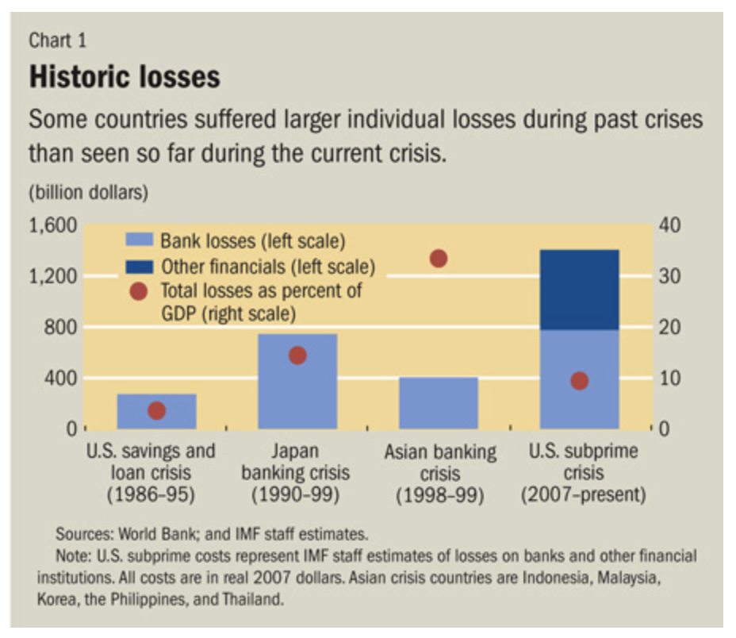

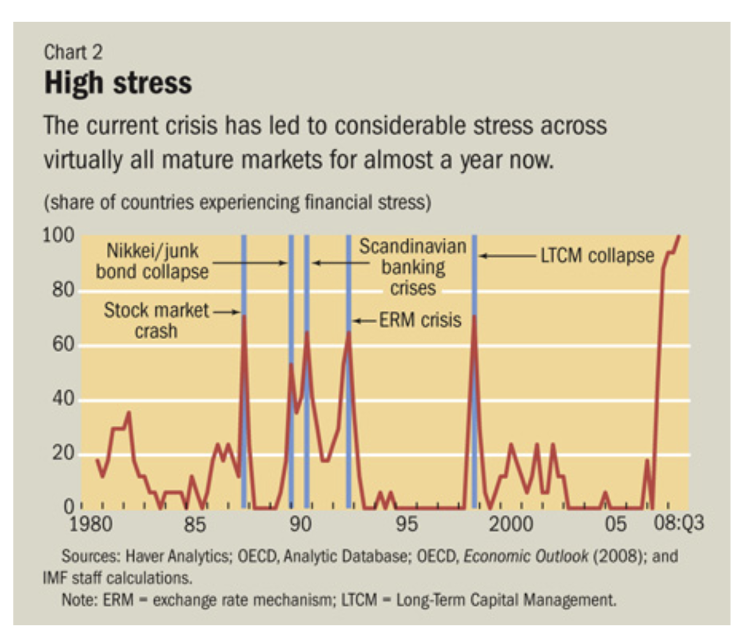

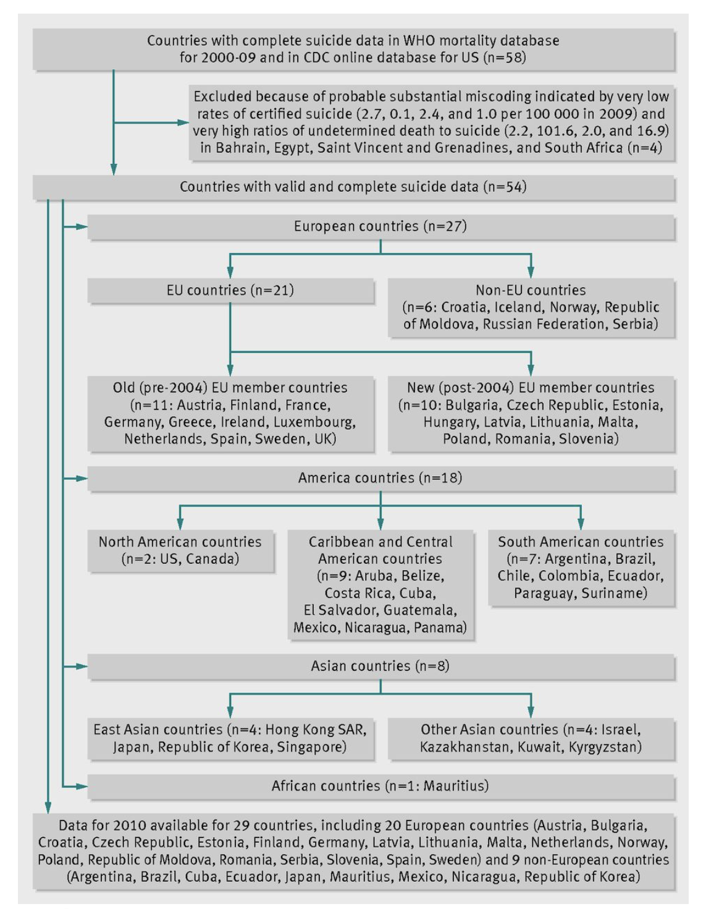

Source: WHO mortality data base, 2010(data collection from 29 countries)



Table 2. US unemployment rate data

Source: [www.tradingeconomic.com](http://www.tradingeconomic.com) Bureau of labor statistics

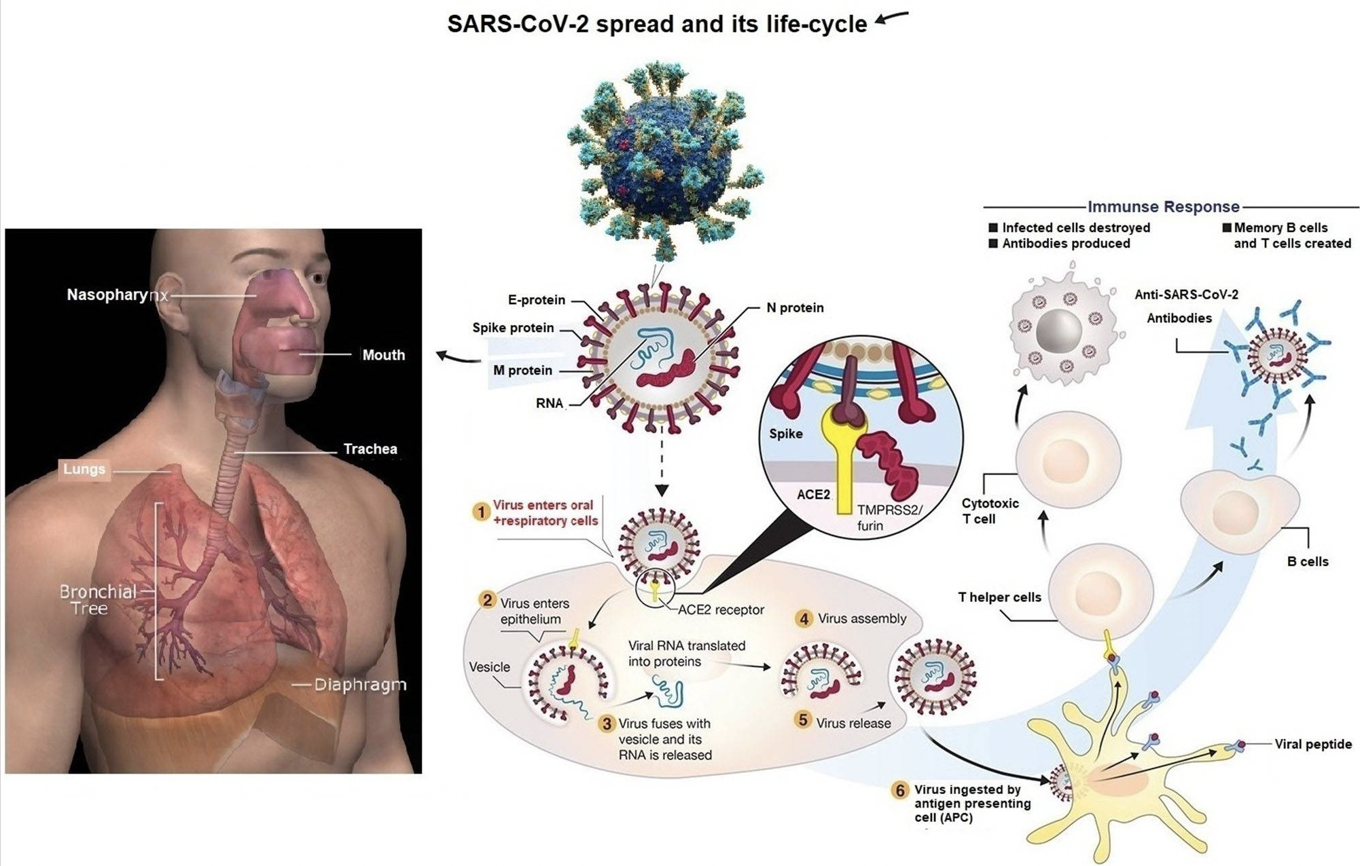

Figure 1. SARS-CoV-2's emergency guidelines, prevent.

Source: WHO declared the guideline data related to the COVID-19 pandemic.

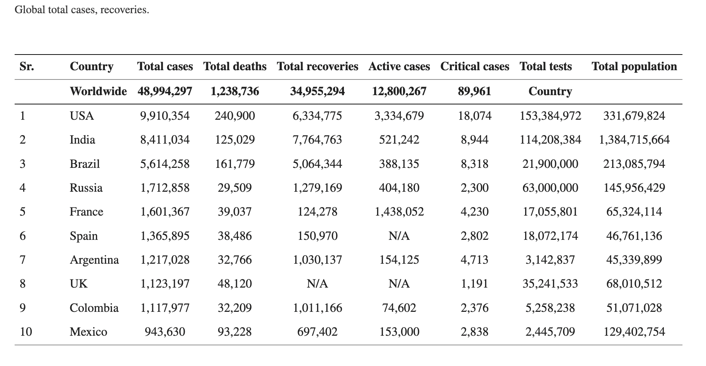

Table 1.

Top 10 Countries Suffered, data of November 5, 2020. Source: COVID-19 CSC data, JHU



Figure: The research ‘onion’, Source: Saunders et al (2008).



TABLE 3. Logistic regression-random choose effect model data



Figure 4. CPI growth Change, CPIF growth, and data from 2000 to 2022 HICP growth in Sweden.